Lulu M. (Byerly) Arnold
March 17, 1900 – May 31, 1976

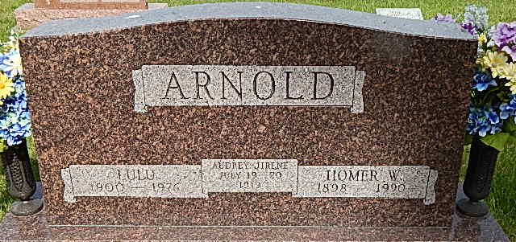

Mrs. Lulu Byerly-Arnold, 76, Route 2, Decatur (S. 13th St.), died at 5:15 p.m. Monday at the Meadowvale Skilled Care Center, Bluffton, after an extended illness.
A homemaker and retired employee of the Adams County Memorial Hospital, she was a member of St. Mark's United Methodist Church. She was born on March 17, 1900 in Kirkland Township in Adams County, the daughter of Daniel M. and Dora Husson-Byerly, and was married on March 15, 1919 to Homer W. Arnold, who survives.
Also surviving are five sons, Stanley D. Arnold of Route 6, Eugene B. Arnold of Route 4, Don H. Arnold of Milford, Homer Arnold of Route 2 and Bill L. Arnold of Route 5, Wabash; two sisters, Mrs. Charles (Mabel) Neuenschwander and Mrs. William (Glennys) Schwartz, both of Fort Wayne; one brother, Lloyd Byerly, Route 4; 18 grandchildren and 12 great-grandchildren. A daughter, six brothers and a sister preceded her in death.
Funeral services will be held at 2 p.m. Thursday at Winteregg-Linn & Haggard Funeral Home, Rev. Fuhrman Miller in charge, and burial will be in the Pleasant Dale Cemetery.
Friends may call at the funeral home after 7 tonight. Preferred memorials are to the St. Mark's United Methodist Church Memorial Fund.
Decatur Daily Democrat, Adams County, IN; June 1, 1976

Contributed by Karin King

