Richard L. Arnold
April 12, 1910 – September 27, 1975

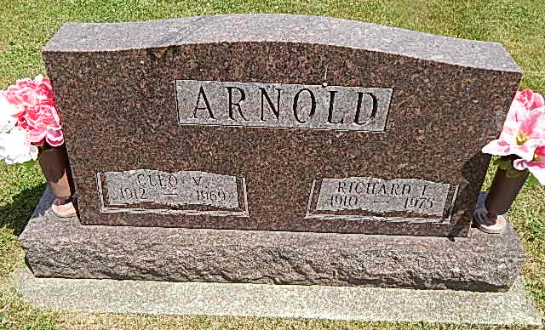

Richard L. Arnold, 65, Route 2, Decatur, a retired farmer, died suddenly at 10:02 p.m. Saturday at the Adams County Memorial Hospital after suffering a heart attack. He was a member of the Methodist Church and the Moose Lodge in Decatur.
He was the son of Edward L. and Eliza Johnston-Arnold and was a lifelong resident of Adams County. He was married in 1934 to Cleo Werling, who died in 1969, and on November 29, 1972, he married Gladys Darr, who survives.
Other survivors include one son, David L., Fort Wayne; two daughters, Mrs. Richard (Marilyn) Rowdon, Fort Wayne and Mrs. Ronald (Dian) Maines, New Haven; two stepdaughters, Mrs. Stuart (Judity) Crabill, New Haven, and Mrs. Jerry (Cheryl) Kelsey, Willshire, O.; one stepson, James Darr, Fort Wayne; two brothers, Lowell, Fort Wayne; Paul, Route 2, Decatur; 11 grandchildren and five step-grandchildren.
Funeral services will be held at 10:30 a.m. Wednesday at the Winteregg-Linn & Haggard Funeral home, with Rev. Oliver P. Dearing officiating. Burial will be in the Pleasant Dale Cemetery.
Friends may call from 7 to 9 p.m. today, and Tuesday from 2 to 4 and 7 to 9 p.m. Preferred memorials are to the Vera Cruz Opportunity School.
Decatur Daily Democrat, Adams County, IN; September 29, 1975

