Harold V. Barger
October 8, 1912 – April 4, 1992

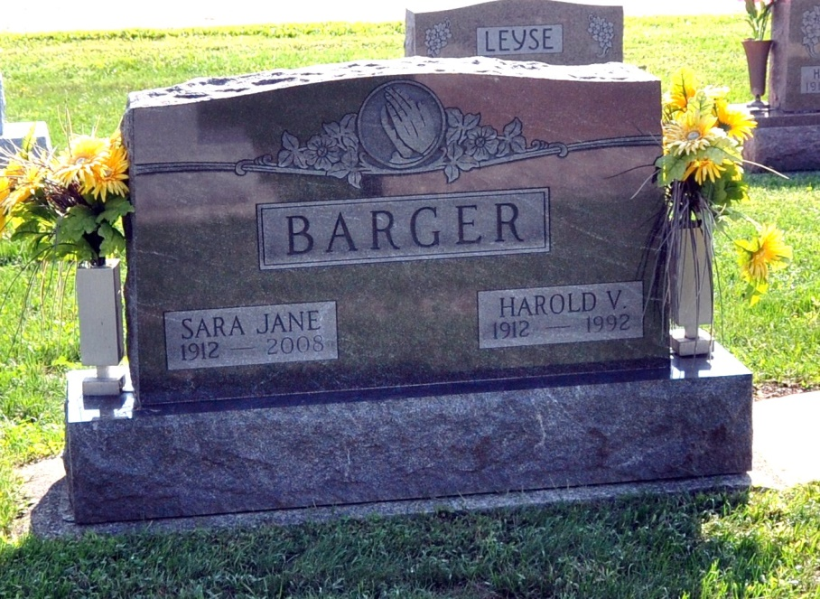
Photo by Deb Curry

A resident of Decatur, Harold V. Barger, 79, died at 1:05 a.m. Saturday at Swiss Village at Berne. Death was the result of heart surgery one year ago. Born Oct. 8, 1912 in Adams County, he was a son of Jacob and Verda Shimer Barger. His marriage to Sara Jane Kaehr, who survives, took place Sept. 15, 1930.
Mr. Barger, a retired farmer, drove a bus for the Adams Central School District 31 years. He served as Kirkland Twp., Adams County, trustee and assessor for 12 years. He was a member of the Pleasant Dale Church of the Brethren and Country Friends Club.
Surviving, in addition to his wife, are two daughters, Mrs. Adrian (Mary Lou) Sprunger of Richmond, Mo., and Mrs. Robert (Patricia) Mitchel of Decatur; a son, Phillip H. Barger of Decatur; a sister, Mrs. Lela Bell of Fort Wayne, 12 grandchildren, 36 great-grandchildren and one great-great-grandchild.
Calling will be from 2 to 5 p.m. and 7 to 9 p.m. today at the Haggard and Armes Funeral Home at Decatur. The body will lie in state one hour prior to services at 11 a.m. Tuesday the Pleasant Dale Church of the Brethren. Rev. Norman Replogle will officiate, and burial will be in the church cemetery.
Memorial may be made to the improvement fund of Mr. Barger's church or Swiss Village.

Bluffton News-Banner, Wells County, IN; April 6, 1992

