Florence C. (Werling) Baumgartner
August 19, 1910 – November 27, 1994

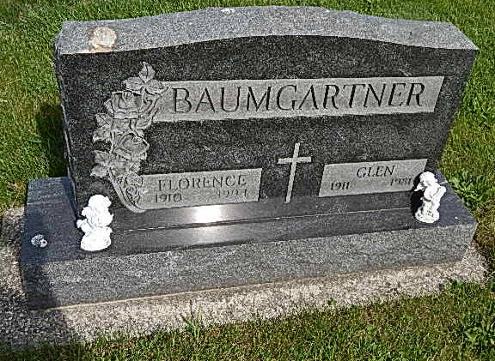
Photo by Alicia Kneuss
Adams Public Library System (Decatur, IN) online obit abstracts
Publication: Decatur Daily Democrat; Date: 28 NOV 1994
Title: Baumgartner, Florence C.;
Subject: Obituaries -- B -- 1990-1999
Abstract: Age 84
Died: Sunday, November 27, 1994
Born: August 19, 1910
Daughter of: Albert & Rosy Scherry Werling
Married: Glen J. Baumgartner on May 22, 1931
Notes: DPL Scrapbook 9-252-2

