Jacob Baumgartner
December 2, 1865 – January 4, 1936

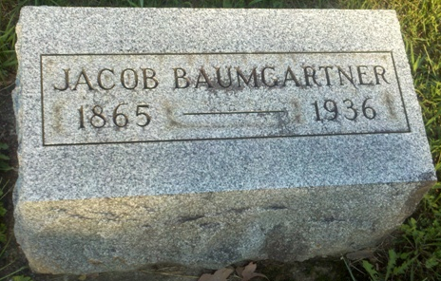
Photo by T & R Melton
Jacob Baumgartner Dies Tuesday Night
Death Occurs in French Township; Funeral Thursday at Pleasant Dale
Jacob Baumgartner, 71, died at 9 o'clock Tuesday night at his home in French Township, Adams County, after an illness of one week, following a stoke of paralysis. Born in Virginia on Dec. 2, 1865, he was a son of Peter and Mary Hawkins Baumgartner. His marriage to Sadie Rogers took place in Decatur on July 18, 1930.
Surviving are the widow, and the following brothers and sisters: Mrs. William Smith, near Monroe; Samuel Baumgartner, of Fort Wayne; Peter, Alfred, and Miss Lizzie Baumgartner, all of Bluffton; Lawrence Baumgartner, of Waterloo; Joe Baumgartner, of Adams County, and Mrs. Hattie Neals, of Decatur.
Mr. Baumgartner was a member of the Methodist church.
Funeral services will be held at 2 o'clock Thursday afternoon at the Pleasant Dale Church. Burial will be in the church cemetery. The body will be at the Jahn Funeral Home until time for funeral services, which will be conducted by Rev. John O. Hensley, of Craigville.
Bluffton Evening News-Banner
February 5, 1936

