Rhea Hope (Byerly) Bryan
1906 – December 8, 1995

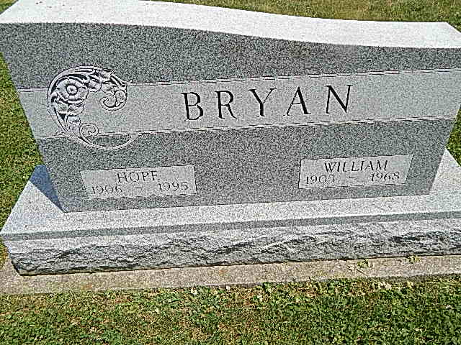
Photo by Alicia Kneuss
Rhea Hope Bryan, 89, of Berne died Friday in Caylor-Nickel Medical Center. The Adams County native was the widow of William C., who died in 1968.
Surviving are a daughter, Marilyn Spensley of Erie, Pa.; son, Edwin C. of Decatur; sister, Faith Myers of St. Augustine, Fla.; and five grandchildren.
Services are 10:30 a.m. tomorrow in Pleasant Dale Church of the Brethren, Decatur, with burial in the church cemetery. Calling is 2 to 5 and 7 to 9 p.m. today in Haggard & Armes Funeral Home, Decatur, and 9:30 to 10:30 a.m. tomorrow in the church. Preferred memorials are gifts to the church's building fund, or Care and Share fund.

News-Sentinel
December 11, 1995

