Jonathan C. Bryan
August 23, 1968 – September 11, 1985

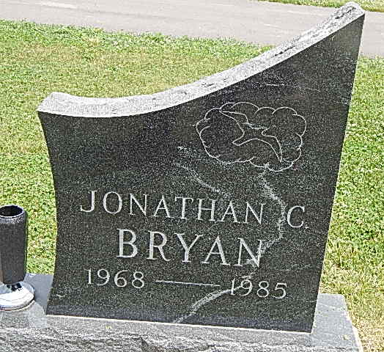
Photo by Alicia Kneuss
Saturday Services at 11:30 a.m. Planned for Jonathan Bryan, 17
Services for Jonathan C. Bryan, 17, son of Mr. and Mrs. Edwin Bryan, of Decatur Route 2, will be held Saturday at 11:30 a.m. at Pleasant Dale Church of the Brethren, Rev. Norman L. Replogle will officiate at the services and burial will be in the church cemetery.
Friends may call at Winteregg-Linn & Haggard Funeral Home in Decatur from 2-5 and 7-9 p.m. today.
Memorials are to the Pleasant Dale Youth Fellowship for National Youth Conference, Estes Park, Colo., and the Pleasant Dale Building Fund.
The youth died in an auto crash Wednesday in Adams County.
A junior at Adams Central, he was a member of the football team, the student council, Fellowship of Christian Athletes, and Campus Life. He was a member of Pleasant Dale Church of the Brethren and the CBYF of the church, of which he was a past president.
Born in Allen County Aug. 23, 1968, he was a son of Edwin and Bonnie Gibson-Bryan.
Survivors, in addition to the parents, are two brothers, Chad Bryan, a student at Purdue University, and Nat Bryan, a student at Manchester College; one sister, Mrs. John (Lisa) Schmitt of Mishawaka; and the paternal grandmother, Mrs. William (Hope) Bryan of Decatur Route 2.
Bluffton News-Banner, Wells County, IN; September 13, 1985

