Rev. Daniel M. Byerly
September 25, 1866 – December 7, 1935

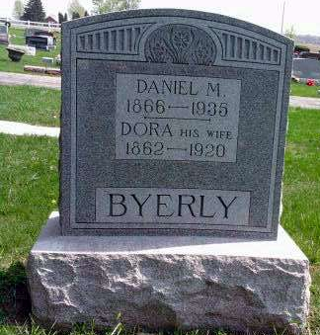
Photo by Deb Curry

Rev.Byerly Dies Today
Former Pleasant Dale Pastor Dies at Fort Wayne This A.M.
The Rev. D. M. Byerly 69, one of the pioneers of Adams County and builder of the Byerly Homestead in Kirkland Township died at the home of his daughter, Mrs. William Schwartz in Fort Wayne at 5 o'clock this morning of apoplexy.
Rev. Byerly made his home with the Dean Byerly family in Kirkland Township and had been visiting his daughter at the time of his death.
On November 26, Rev. Byerly suffered a severe heart attack and was believed to be recovering.
The deceased was born near Lima Ohio, on September 25, 1866. He was married on February 14, 1888 to Miss Dorothy Hueson who preceded him in death on September 3, 1920. To this union were born 11 children, two of whom died in infancy. The following children survive: Mrs. Etta Taylor or Pennville, Dean Byerly, Lloyd Byerly and Mrs. Lulu Arnold of Decatur; Clint and Ray Byerly of Craigville; Mrs. Mabel Neuenschwander and Mrs. Glennys Schwartz of Fort Wayne and Chester Byerly of Ossian.
In the fall of 1921 Rev. Byerly married Mrs. Lulu Paulling Mendenhall of Huntington, who survives.
There are five brothers, three sisters, 29 grandchildren and two great grandchildren surviving.
In his early life Rev. Byerly taught in the public schools in Ohio. He moved to Adams County in the spring of 1888, and located in Kirkland Township where he assisted in the founding of the Pleasant Dale Church of the Brethren. He was ordained to the ministry in 1889. Failing health caused his retirement from the ministry in 1932. During his ministry he served 10 years as president and secretary of the general mission board of the middle district of Indiana.
The body will be removed from the Lobenstein Funeral Home in Monroe at 4:30 o'clock this afternoon and may be viewed by friends at the Dean Byerly home after 6 o'clock.
Funeral services will be held at the Pleasant Dale church at 2 o'clock Monday afternoon. The Rev. Otho Winger, president of Manchester College at North Manchester, assisted by the Rev. Russell Weller, pastor of the Pleasant Dale church will conduct the services.
Decatur Daily Democrat, Adams County, IN; December 7, 1935

