Isabelle Nora (Lash) Chronister
June 30, 1915 – February 15, 1990

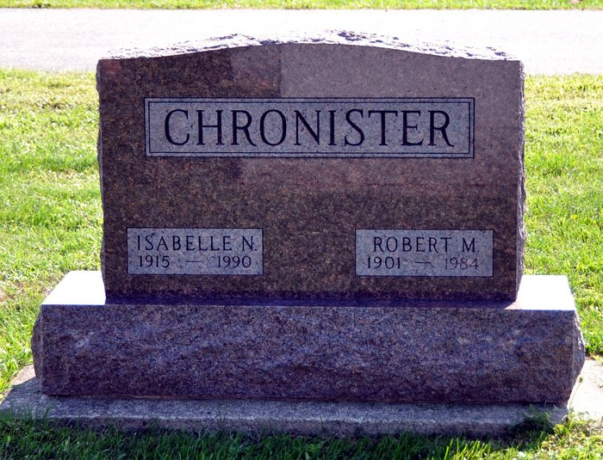
Photo by Deb Curry

Nora I. Chronister, 74, Fort Wayne, a former Decatur resident, died at 8:20 p.m. Thursday in Parkview Memorial Hospital, Fort Wayne.
She was born on June 30, 1915 in Wells County to Brandon and Pearl Landis Lash and married Robert Chronister Sr. on August 8, 1942; he died on July 2, 1984. She was a member of Pleasant Dale Church of the Brethren.
Surviving are two sons, Robert Chronister, Yoder, and Ronald Chronister, Fort Wayne; two brothers, Don Lash, Crawfordsville, and Charlie Lash, Brook, Indiana; one sister, Jean Lash, Fort Wayne; and five grandchildren.
Funeral services are at 11 a.m. Monday in Pleasant Dale Church of the Brethren, Rev. Norman Replogle officiating. Burial will be in the church cemetery. Visiting hours at Haggard and Armes Funeral Home are 3-5 and 7-9 p.m. Sunday; there is visitation at the church from 10-11 p.m. Monday. Preferred memorials are to the Pleasant Dale Church of the Brethren Building Fund.

Decatur Daily Democrat, Adams County, IN; February 17, 1990

Contributed by Karin King

