Robert Milton Chronister
February 17, 1901 – July 2, 1984

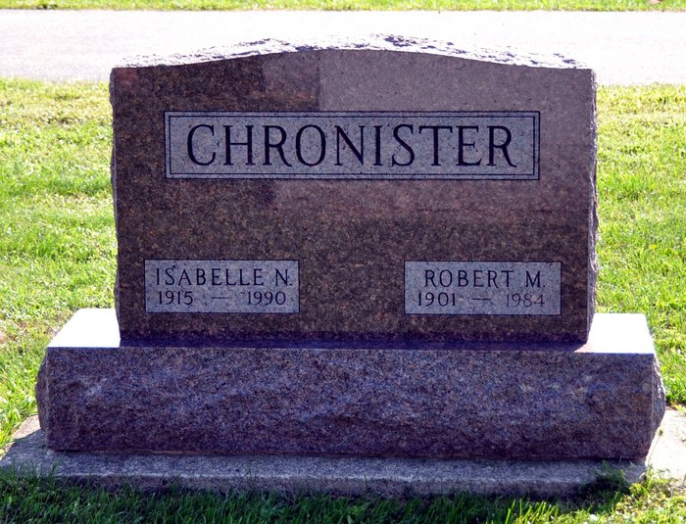
Photo by Deb Curry

Robert M. Chronister, 83, 288 Stevenson St., who retired from the Central Soya Co. in 1966 after 25 years of service, died at noon Monday at the home of a son in Fort Wayne, following an extended illness. A member of the Pleasant Dale Church of the Brethren, he was born in Adams County on Feb. 17, 1901, the son of Edward and Jessie Zimmerman-Chronister, and was married Aug. 8, 1942, to Nora Lash; she survives.
Also surviving are two sons, Robert E. Chronister and Ron Chronister, both of Fort Wayne; and four grandchildren. One sister preceded him in death.
Services will be held at 10 a.m. Wednesday in Pleasant Dale Church of the Brethren, Norman L. Replogle officiating. Burial will be in the church cemetery. Friends may call at the Winteregg, Linn & Haggard Funeral Home from 204 and 7-9 p.m. today. The body will lie in state one hour prior to services.
Decatur Daily Democrat, Adams County, IN; July 3, 1984

Contributed by Karin King

