Lola E. (Barger) Ehrman
January 21, 1903 – February 16, 1992

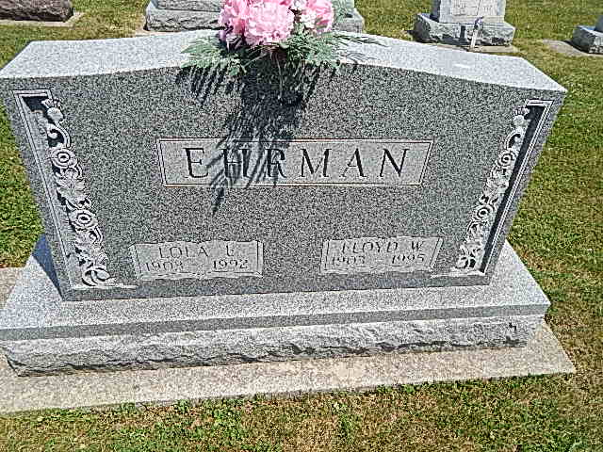
Photo by Alicia Kneuss
Lola E. Ehrman, 89, of Decatur died yesterday at the Swiss Village Nursing Home, Berne. She was a homemaker.
Surviving are her husband, Floyd; a son, Hugh of Decatur; a daughter, Ilene Reinhard of Craigville; sisters, Alta Byerly of Berne and Aleta Byerly of California; nine grandchildren; and 19 great-grandchildren.
Services are 11 a.m. Wednesday at the Pleasant Dale Church of the Brethren, Decatur. Calling is 2 to 5 and 7 to 9 p.m. tomorrow at Haggard & Armes Funeral Home, Decatur, and 10 to 11 a.m. Wednesday at the church. Burial will be in Pleasant Dale Cemetery.
Preferred memorials are gifts to Swiss Village Nursing Home or Gideon’s International.

Fort Wayne News-Sentinel (IN); February 17, 1992
Contributed by Jane Edson

