Douglas Lee Fairchild
December 1, 1990 – December 10, 1990

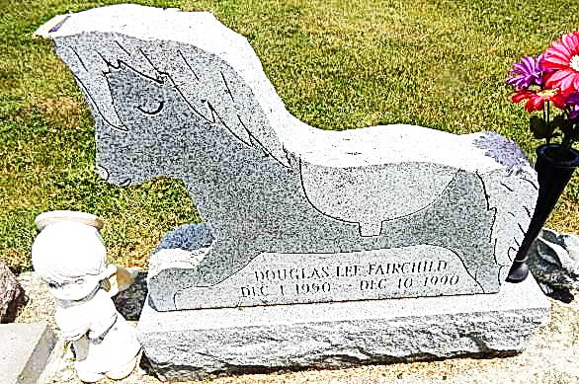
Photo by Deb Curry

Grandson of Bluffton Resident Dies At 10 Days; Services Set
The grandson of a Bluffton resident, Douglas Lee Fairchild, 10 days old, died at 10:23 p.m. Monday at Parkview Hospital.
Surviving are his parents, Walter L. and Jill C. Fairchild; two brothers, Dennis and Walter, at home; grandparents, Walter "Shorty" and Phyllis Fairchild of Geneva, Connie Bogner of Bluffton, and Alan and Linda Bogner of Fort Wayne; and great- grandparents, Richard and Flossie Bogner of Decatur, and Thurman and Sarah Douglas of Berne.
Graveside services at 2 p.m. Thursday will be at Pleasant Dale Cemetery in Adams County.
Arrangements were made by Haggard & Armes Funeral Home, Decatur. Preferred forms of memorial are to the Parkview Hospital Neonatal Unit.
Bluffton News-Banner, Wells County, IN; December 12, 1990

