Ralph R. Freels
August 9, 1907 – July 21, 1990

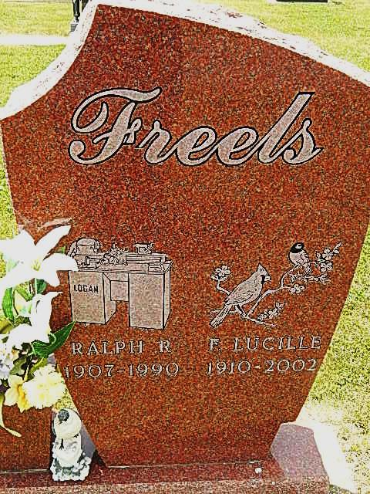
Photo by Alicia Kneuss

Gas leak eyed
Investigators believe leaking natural gas may have set off an explosion and raging fire that claimed the life of an elderly Adams county man late Saturday morning.
Ralph R. Freels, 82, route 4, Decatur, died of smoke inhalation, according to deputy Adams County Deputy Coroner Gayle Armes.
The explosion and fire destroyed the house in which he and his wife resided. The home is located on County Rd. 700 West, the Adams-Wells county line, near County Rd. 200 North, in Kirkland Township.
Mr. Freels, who is believed to have been trying to light a pilot light in the house when the blast occurred, was able to make his way almost to the back door before collapsing. His wife, Lucille, who was working in the garden behind the house, used a garden hose to wet the burning building to give her husband a chance to escape.
Mrs. Freels was not hurt. Some reports said a neighbor suffered hand burns while trying to help during the initial stages of the fire. No confirmation was available today, however, as several of those involved in the investigation knew nothing about some supposedly being injured.
Funeral services for Mr. Freels are scheduled for 2 p.m. Tuesday at Pleasant Dale Church of the Brethren. Calling is from 2-9 p.m. today at Haggard and Armes Funeral Home, and at the church one hour prior to services Tuesday. A complete obituary notice is on page 2.
Some 25-30 firefighters from three departments in Adams and Wells counties fought the fire, but could not save the home or any of the family possessions.
This morning, Preble Fire Chief Warren Scheumann estimated that damage to the home and its property could amount to $50,000 to $60,000.
Firefighters came from the Preble, Bluffton, and Monroe departments. Bluffton firefighters were dispatched first, then the Preble department was sent when it was reported that the Freel’s house was on the Adams County side of the county line road.
Bluffton firemen were sent at 10:16 a.m. and were at the scene until 12:45 p.m. Preble firemen were sent at 10:22 a.m. and were at the scene until 12:03 p.m.
The Freels couple lived in the house for many years and had returned from a vacation trip only the day before.
Fire Chief Scheumann said the explosion was heard up to a mile away. Armes said a passerby who either saw or heard the blast called in the alarm.
Charred remains...
...Badly charred house on route 4, Decatur continues to burn Saturday morning after Ralph R. Freels, 82, perished. Mr. Freels and his wife, Lucille, lived there many years, but Mrs. Freels was outside the home when an explosion set off the fire. She was unhurt. The home is on the Adams-Wells county line road, CR 700 West, just south of Curryville and just west of Craigville.
Decatur Daily Democrat, Adams County, IN; July 23, 1990, p. 1
*****

Ralph R. Freels, 82, route 4, Decatur, died around 10 a.m. Saturday of smoke inhalation after an explosion in his home on the Adams-Wells County Line Road. He was born in Whitley County on August 9, 1907 to Orva and Effie Smith Freels and married Frances Lucille Henschen on June 4, 1932; she survives.
He was a well-known Kirkland Township farmer and also owned and operated Freels' Machine Works of Decatur and Freels' Charter Service in Michigan City, Indiana. He retired in 1970 from International Harvester's Fort Wayne plant.
He was a member of Pleasant Dale Church of the Brethren and was a member of the National Rifle Association.
Other survivors are two daughters, Mrs. Gene (Elaine) Bluhm, route 1, Monroe, and Mrs. Ronald (Arleen) Corson, Syracuse, Indiana; a son, Allen Freels, Albion; a sister, Mrs. Lloyd (Ella) Schuller, Chicago, Illinois; eight grandchildren; and 11 great-grandchildren. One brother and one sister are deceased.
Funeral services are at 2 p.m. Tuesday in Pleasant Dale Church of the Brethren, Rev. Norman Replogle officiating. Burial will be in the church cemetery. Pallbearers will be Jan Bluhm, Jed Freels, Jeffrey Bluhm, Jeremy Corson, Jason Bluhm, Brian Bluhm, and Kyle Bluhm.
Visiting hours are 2-9 p.m. today at Haggard and Armes Funeral Home and 1-2 p.m. Tuesday at the church. Preferred memorials are to the building fund of Pleasant Dale Church of the Brethren.
Decatur Daily Democrat, Adams County, IN; July 23, 1990, p. 2
*****
Services Tuesday for Ralph R. Freels, 82, of Rural Decatur
Funeral services will be held Tuesday for Ralph R. Freels, 82, who died at approximately 10 a.m. Saturday at his Route 4, Decatur residence on the Wells/Adams County line. His death was caused by a fire.
Born August 9, 1907 in Whitley County, he was a son of Orva and Effie Smith Freels. His marriage to the former Frances Lucille Henschen, who survives, took place June 4, 1932 in Columbia City.
Mr. Freels retired in 1970 from the precision measuring lab at International Harvester. He was the owner and operator of Freels Charter Service of Michigan City, and Freels Machine Works at Decatur. He was a member of the Pleasant Dale Church of the Brethren and a charter member of the National Rifle Association and an avid big game hunter.
In addition to the wife, survivors include one son, Allen Freels of Albion; two daughters, Mrs. Gene (Elaine) Bluhm of rural Monroe, and Mrs. Ronald (Arleen) Corson of Syracuse; one sister, Mrs. Lloyd (Ella) Schuller of Chicago, Ill.; eight grandchildren and 11 great-grandchildren.
The body will lie in state one hour prior to the 2 p.m. funeral services Tuesday, under the direction of Rev. Norman Replogle, at the Pleasant Dale Church of the Brethren.
Friends may call from 2 to 9 p.m. today at Haggard and Armes Funeral Home, Decatur.
Preferred forms of memorial are gifts to the Pleasant Dale Church of the Brethren building fund.
Bluffton News-Banner, Wells County, IN; July 23, 1990

