Peter M. Fulk
March 25, 1847 – February 8, 1932

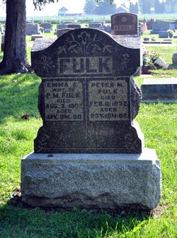
Photo by Deb Curry
Peter Fulk Dies Monday
Aged Man Known Here Dies At Home of Son in Philo, Ohio
Peter M. Fulk, 84, well known in Adams and Wells Counties died at 8 o'clock. Death resulted from old age and complications. Mr. Fulk was born in Warren Ohio, March 25, 1847.
Surviving are three sons, Dr. Fulk and Arthur and John Fulk of Bluffton. His wife Emma and a son Jacob preceded him in death.
The remains were taken to the home of John Fulk at Bluffton and funeral services will be conducted at that place 421 West Lancaster Street, Wednesday afternoon at 2 o'clock. Burial will be made at Pleasant Dale Cemetery.
Decatur Daily Democrat, Adams County, IN; February 9, 1932
*****
PETER M. FULK TAKEN BY DEATH
PASSES AWAY AT HOME OF SON IN OHIO; BODY BROUGHT BACK HERE
Peter M. Fulk, 84, a former resident of Wells and Adams Counties, died at 8 o'clock Monday evening at the home of a son, Dr. M. E. Fulk, at Philo, Ohio. He had been in poor health and his death is attributed to infirmities of his advanced years.
Mr. Fulk was born at Warren, Ohio, on March 25, 1847, and at his death was aged 84 years, ten months and eight days. He was a resident of Decatur for a number of years, and also made his home in this city at one time with a son, John A. Fulk. His wife, Emma Fulk, has been dead a number of years.
Surviving are three son, Dr. M. E. Fulk, Philo, Ohio; Arthur and John A. Fulk, this city. One son, Jacob, is deceased.
The body will be brought here to the home of the son, John A. Fulk, 421 West Lancaster Street.
Funeral services will be held at 2 o'clock Wednesday afternoon at Pleasant Dale, with burial in the Pleasant Dale Cemetery.
Evening News-Banner, Wells County, IN; February 9, 1932

