Naomi M. (Deeren) Griffiths
October 28, 1907 – February 9, 1986
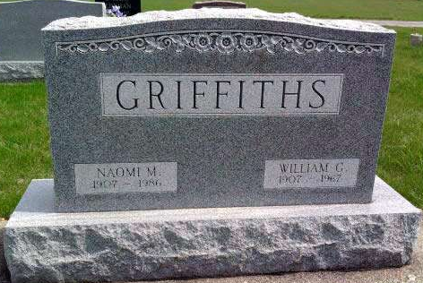
Photo by Deb Curry

Mrs. William Griffiths Dies; Wells Native; Retired Teacher
Retired school teacher, and native of Wells County, Mrs. William (Naomi M.) Griffiths, 78, of Decatur Route 2 died at 12:07 a.m. Sunday in Decatur hospital following an extended illness.
Mrs. Griffiths, who retired in 1969, was a teacher for 31 years, during which time she filled posts in the Petroleum and Poplar Grove Schools.
A member of the Pleasant Dale Church of the Brethren and its Women's Fellowship, she was a former 4-H club leader and a member of the Kirkland Home Economics Club.
Born October 28, 1907, in Wells County, she was a daughter of George and Verna Schooley Deeren. Her marriage to William G. Griffiths, who died in 1967, took place January 6, 1935.
Surviving are two sons, Nolan Griffiths and Keith Griffiths, both of Decatur Route 2; two daughters, Mrs. Bobby (Margaret) Robinson of Route 1 Rockford, Ohio, Mrs. Marvin (Evelyn) Zurcher, of Berne, 11 grandchildren, four step-grandchildren and five great- grandchildren.
From 7 to 9 p.m. today and 2 to 5 and 7 to 9 p.m. Tuesday friends may be received at the Winteregg, Linn and Haggard Funeral Home in Decatur.
At 10 a.m. Wednesday the body will be taken to the Pleasant Dale Church of the Brethren for services at 11 a.m. in charge of Rev. Norman Replogle. Burial will be in the church cemetery.
Preferred are memorials to the Pleasant Dale Church of the Brethren building fund.
Bluffton News-Banner, Wells County, IN; February 10, 1986

