Thomas John Griffiths
July 3, 1881 – February 10, 1958
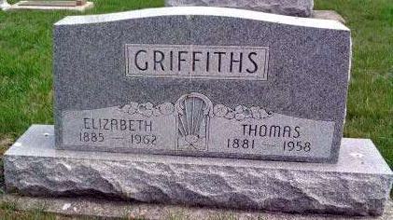
Photo by Deb Curry

Thomas Griffiths Dies Monday Night
Kirkland Township Farmer Dies Here
Thomas Griffiths, 76, retired farmer of Kirkland Township, two miles south of Magley, died at 10:40 o'clock Monday night at the Adams County Memorial Hospital, where he had been a patient for the past two weeks. He was born near Elida, O., July 3, 1881, a son of John and Nancy Brenneman - Griffiths, and was married to Elizabeth Berger September 20, 1906.
Mr. Griffiths was a member of the Pleasant Dale Church of the Brethren.
Surviving in addition to the wife are three sons, William G. Griffiths of Kirkland Township, Herman A. Griffiths of Huntington County, and Glen T. Griffiths of Kirkland Township; one daughter, Mrs. Reinhold (Leah) Koldewey of Hagerman, Ida.; 13 grandchildren; one great-grandchild; three half-brothers, Martin Gahman of Wells County, Ottomar Gahman of Detroit, Mich., and Floyd Gahman of New York City, and four half-sisters, Mrs. Frank Bright of Wells County, Mrs. Charles Hogg of near Bluffton, Mrs. Clarence Abbott of Convoy, O., and Mrs. Clare Odell of Lima, O. A half- sister preceded him in death.
Funeral services will be conducted at 1:30 p.m. Thursday at the Zwick Funeral Home and at 2 p.m. at the Pleasant Dale Church of the Brethren, the Rev. John Mishler officiating. Burial will be in the church cemetery. Friends may call at the funeral home after 7 o'clock this evening until time of the services.
Decatur Daily Democrat, Adams County, IN; February 11, 1958
*****
Thomas Griffiths Claimed by Death
Thomas Griffiths, 76, a retired farmer who resided two miles south of Magley in Kirkland Township, died Monday in the Adams County Memorial Hospital, where he had been a patient two weeks.
He was born July 3, 1881, near Elida, O., and was a member of the Pleasant Dale Church of the Brethren.
Surviving are the widow, the former Elizabeth Berger, to whom he was married September 20, 1906; three sons, William G. and Glen T. Griffiths, Kirkland Township, and Herman Griffiths, Huntington; a daughter, Mrs. Reinhold Koldeway, Hagerman, Ida.; 13 grandchildren; a great-grandchild; three half-brothers, Martin Gahman of Wells County, Ottomar Gahman, Detroit, and Floyd Gahman, New York City, and four half-sisters, Mrs. Frank Bright of Wells County; Mrs. Charles Hogg, near Bluffton; Mrs. Clarence Abbott, Convoy, O., and Mrs. Clare Odell, Lima, O.
Services will be conducted Thursday at 1:30 p.m. in the Zwick Funeral Home and at 2 o'clock in the Pleasant Dale Church of the Brethren, Rev. John Mishler officiating. Burial will be in the church cemetery.
Bluffton News-Banner, Wells County, IN; February 12, 1958

