Mary E “May” (Melching) Heller
September 21, 1889 – November 23, 1974

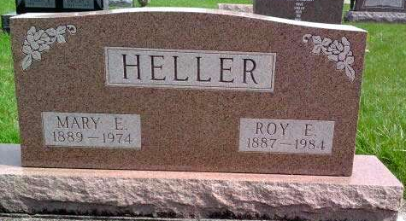
Photo by Deb Curry
Local woman dies Saturday at hospital
Mrs. Mary Heller, 85, of route 4, died at 7:40 p.m. Saturday at the Adams County Memorial Hospital. She has been in failing health for the past two years. She was a member of the Christian Church at Craigville.
Born in Wells County on September 21, 1889, she was the daughter of Daniel and Lydia Johns-Melching, and was married November 24, 1910 to Roy E. Heller, who survives. They would have celebrated their 64th wedding anniversary on Sunday.
Other survivors include a son, Theodore of Route 2, Decatur; three grandchildren and 10 great-grandchildren. A son, Alfred, two brothers and two sisters preceded her in death.
Funeral services are scheduled at 1:30 p.m. Tuesday at the Zwick Funeral Home, with the Rev. Oliver Dearing officiating. Burial will be in the Pleasant Dale Cemetery. Friends may call at the funeral home until time of the services.
Decatur Daily Democrat, Adams County, IN; November 25, 1974

