Franklin Oliver Henschen
September 6, 1893 – January 4, 1919

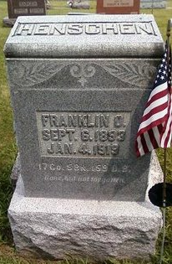
Photo by Deb Curry

ADAMS COUNTY SOLDIER DEAD
DECATUR, Ind. Jan. 6 – Just a few days before he was to be mustered out, the death summons came for Frank Henschen; Adams County soldier at Camp Taylor, Ky. Death was due to pneumonia and spinal meningitis, following influenza, after a few days' illness.
He was a son of Jacob Henschen, of Kirkland Township. He was 25 years of age. He leaves a wife and 5-month-old daughter. The body arrived here last night.

News-Sentinel, Fort Wayne, IN; January 6, 1919

