Pearl P. (Leimenstoll) Hoffman
October 13, 1888 – December 14, 1980

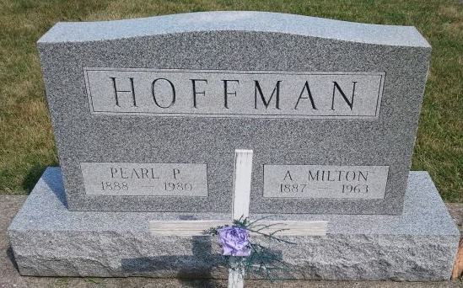
Photo by Deb Curry

Preble Woman, Mrs. Hoffman Dies; Rites Wednesday
Mother of Oscar (Pete) Hoffman of Craigville Route 1 and a resident of Preble, Mrs. Andrew (Pearl) Hoffman, 92, died at 5:33 p.m. Sunday in Decatur Hospital where she had been a patient one week.
A member of the Pleasant Valley United Methodist Church, Mrs. Hoffman was born Oct. 13, 1888 in Adams County to Rinehard and Rachel Martin Leimenstoll. Her marriage to Andrew M. Hoffman, who died in 1963, took place July 31, 1905.
Surviving, in addition to the son, are three daughters, Miss Gertrude Hoffman and Mrs. Bernita Bash, both of Preble, Miss Miriam Hoffman of Fort Wayne; another son, Leo Hoffman of Preble, five grandchildren, 12 great-grandchildren and two great-great-grandchildren.
Calling after 2 p.m. Tuesday will be at the Winteregg-Linn and Haggard Funeral Home in Decatur with services there at 11 a.m. Wednesday in charge of Rev. Edison Reynolds. Burial will be in the Pleasant Valley Church Cemetery.
Bluffton News-Banner, Wells County, IN; December 15, 1980

