Carolyn L. (Liby) Houtz
July 18, 1945 – May 1, 1970

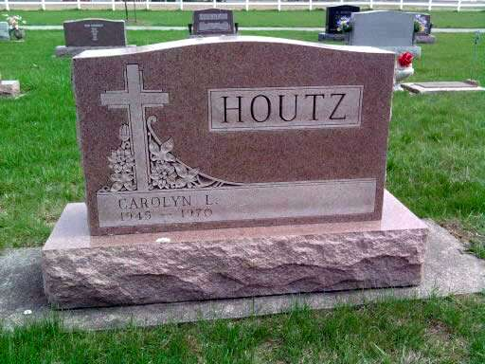
Photo by Deb Curry

Dies 5 Days after Head Injury
Horse-ride Accident Fatal to Mrs. Carolyn Houtz, 24
Mrs. Carolyn Lee Houtz, 24, wife of Dennis Houtz of Uniondale Route 1 and daughter of Mr. and Mrs. Ralph Liby, 314 East Market St., lost a valiant fight for life in the intensive care ward at Parkview Hospital, where she died at 6 p.m. Friday, five days after suffering a massive head injury and severe brain damage when thrown from a horse onto the pavement four miles north of Uniondale on the Uniondale Rd. last Sunday evening.
Unconscious and in grave condition since the accident, the former News-Banner society editor and six-year employee of the newspaper slipped gradually through the week despite the constant use of a respirator to support breathing.
In the final day, intensive care attendants struggled in vain to stabilize her breathing and failing heartbeat.
Her husband remained at the hospital throughout the five days and nights. The parents, a brother and other relatives also maintained a bedside vigil much of the time.
Mrs. Houtz, who was a member of the Circle W Riders, was injured about 8 p.m. Sunday when an Appaloosa horse, purchased only two days earlier, apparently was frightened by traffic and bolted as the young woman was mounting the animal. She was thrown into the air and onto the pavement, with her forehead and right side of her head striking the hard surface.
Born July 18, 1945, in Wells County, she was the daughter of Ralph and Valera Mock Liby. Her marriage to Dennis D. Houtz took place Sept. 11, 1965, at the Pleasant Dale Church of the Brethren in Adams County.
Mrs. Houtz was graduated from Bluffton High School in 1963. She was employed in the office of Bluffton Utilities from June of that year until January of 1964, when she joined the staff of the News-Banner.
The accident victim worked full time for the newspaper until shortly before the birth of her first daughter in the fall of 1966. Later she returned on a part-time basis and subsequently as a full-time employee again prior to the arrival of a second daughter last summer.
Since the 1969 holiday season she once more had been helping frequently on a part-time basis right up to a few days before the accident. In addition to her former services as society editor and general office duties, Mrs. Houtz assisted often and competently in the advertising department.
Throughout the five days after the accident, News-Banner staff members were besieged by anxious inquiries from many friends and acquaintances in her newspaper duties. The same reflection of deep concern was evident in Uniondale, where her husband operates a barber shop.
Mrs. Houtz was a member of the Pleasant Dale Church.
Surviving, in addition to the husband and parents; are the two daughters, Angela, 3, and Andrea, nine months; one brother, Thomas Liby, who is a Manchester College student; a grandmother, Mrs. Nellie Mock of Bluffton Route 3, and a grandfather, Fritz Martz of Monroe.
The body was taken to the Elzey Funeral Home at Ossian, where friends may call after 7 p.m. today until noon Monday. The body will lie in state from 1 to 2 p.m. Monday at the Pleasant Dale Church of the Brethren; 7 1/2 miles east of the Lancaster School on the Lancaster Center Rd.
Services will be at 2 p.m. Monday in the church with Rev. J. Oliver Dearing officiating. Burial will be in the church cemetery.
Bluffton News-Banner, Wells County, IN; May 2, 1970

