Homer H. Houtz
January 23, 1901 – June 27, 1967

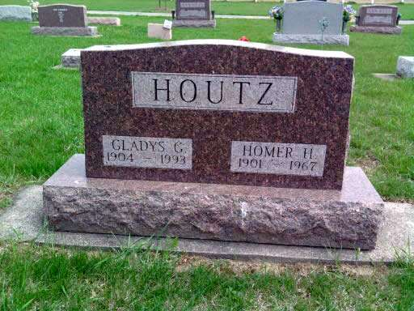
Photo by Deb Curry

Rites Friday for Homer Houtz, 66
Homer Houtz, 66, of Uniondale died at 10 p.m. Tuesday at Wells County Hospital. He had been ill for six months and hospitalized the past four weeks. A son of William H. and Ida Blanche Sale Houtz, he was born Jan. 23, 1901. His marriage to Gladys G. Baumgartner, who survives, took place Jan. 21, 1922 in Hillsdale, Mich.
A native of Wells County, Mr. Houtz was a member of the Uniondale Methodist Church. At one time he operated a grocery store in Uniondale and prior to his illness was employed by the G & L Corp. in Fort Wayne.
Survivors, in addition to the wife, are a sister, Mrs. Charles (Gladys) Fuhrer of Uniondale, and three brothers, Roy of California and Glen and Gerald, both of Uniondale.
Friends may call after 7 p.m. today at the Goodwin Funeral Home in Bluffton until noon on Friday, at which time the body will be taken to the Uniondale Methodist Church for 1:30 p.m. services.
Rev. Joseph Wagner and Rev. Vance Davison will officiate. Burial will be in the Pleasant Dale Cemetery.
Bluffton News-Banner, Wells County, IN; June 28, 1967

