Jessie Edna (Lewton) Kaehr
January 16, 1898 – October 21, 1931

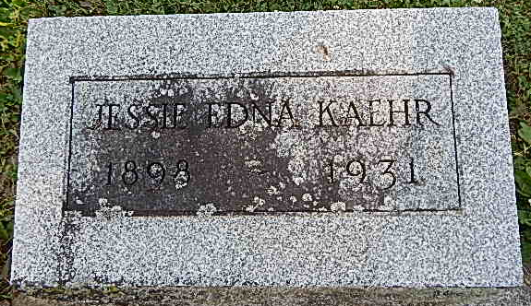
Photo by Alicia Kneuss
Mrs. Jessie Kaehr Dies at Ft. Wayne
Wife of Reuben Kaehr Passes Away at Irene Byron Sanatorium
Mrs. Jessie Edna Kaehr, 33, wife of Reuben Kaehr, Bluffton, died at 5 o'clock this morning at the Irene Byron Sanatorium in Fort Wayne following an illness of six years of tuberculosis. She was born at Preble on Jan. 16, 1898, a daughter of Perry V. and Jennie Zimmerman Lewton, and was 33 years, 9 months and 5 days of age at the time of her death. Her marriage to Reuben Kaehr took place at Hillsdale, Mich., on Sept. 11, 1945 (sic – 1915).
Surviving besides the husband are four children, Marion, Alice, Vernon and Carl, all at home. One sister, Mrs. Geraldine Berry, resides at Toledo, O. Mrs. Kaehr had been a resident of Wells County for the past eight years. She was a member of the Pleasant Dale Church, Adams County.
The body will remain at the McBride Funeral Parlor in Bluffton until shortly before the funeral which will be held at 2 o'clock Friday afternoon at Pleasant Dale Church in charge of Rev. Dan Byerly. Burial will be in the church cemetery.

Bluffton News Banner, Wells County, IN; October 21, 1931

