Earl S. Landis
July 1, 1890 – April 17, 1968

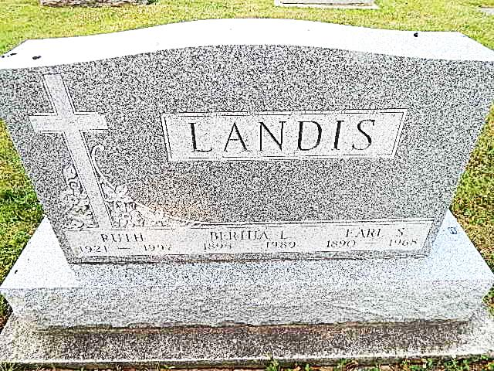
Photo by Alicia Kneuss
Earl S. Landis Dies Early Today
Earl S. Landis 77, retired farmer, died at 1 a.m. today at his home on Monroe Route 1,three miles west of Monroe. He had been in failing health for the past four years. He was born in Darke County, O., July 1, 1890, a son of John H. and Susannah Baker-Landis, but lived most of his life near Monroe. He was married to Bertha Fugate December 25, 1913.
Mr. Landis was a member of the Pleasant Dale Church of the Brethren.
Surviving are his wife; seven sons, Homer, Harvey and Willard Landis, all of Decatur, Arthur Landis of Willshire, O., Herman and Cleo Landis, both of Columbia City, and Clifford Landis of Monroe; two daughters, Miss Ruth Landis of Monroe, and Mrs. Gene (Marie) Mitchel of Decatur; one brother, Jesse Landis of Bluffton; four sisters, Mrs. George (Alice) Effinger of Cape Coral, Fla., Mrs. Elmer (Clara) Banks of Tucson, Ariz., Mrs. Herman (Rose) Wise of Piqua, O., and Mrs. Damon (Mary) Cornelious of Richmond; 21 grandchildren and one great-grandchild. One son and three brothers are deceased.
Funeral services will be conducted at 1:30 p.m. Saturday at the Pleasant Dale Church of the Brethren, with Rev. Dolar Ritchey officiating. Burial will be in the Pleasant Dale Cemetery. Friends may call at the Zwick Funeral Home after 7 p.m. Thursday until 11a.m. Saturday. The body will lie in state at the church from 12 noon Saturday until the time of the services.

Unknown source

