Harvey E. Landis
June 24, 1920 – August 20, 1990

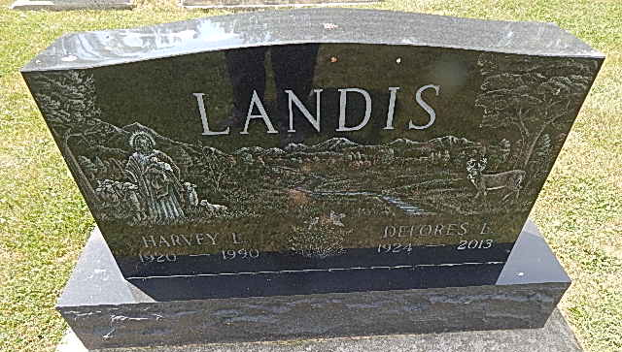
Photo by Alicia Kneuss

Landis & Sons Farm Drainage Founder, Harvey Landis Dies
The founder of Landis & Sons Farm Drainage, Harvey E. Landis, 70, of rural Decatur, died unexpectedly early Monday morning at his residence. Born June 24, 1920 in Kirkland Twp., Adams County, he was a son of Earl S. and Bertha L. Fugate Landis. His marriage to the former Delores E. Byerly, who survives, took place June 21, 1947 in Adams County.
Mr. Landis founded the drainage company in the 1940's and was a member of the Land Improvement Contractors of America for 30 years. He was also a member of the Pleasant Dale Church of the Brethren and its finance and trustee boards.
In addition to the wife, survivors include four sons, Steve E. Landis of Bluffton, and Robin J. Landis, Randy R. Landis and Tony L. Landis of rural Decatur.
Also surviving are two sisters, Mrs. Gene (Marie) Mitchel of rural Decatur, and Ruth Landis of Decatur; five brothers, Arthur Landis of Decatur, Herman Landis and Cleo J. Landis of rural Columbia City, Willard Landis of rural Decatur, and Clifford Landis of rural Monroe; eight grandchildren, three step grandchildren and one step great-grandchild.
Funeral services will be conducted by Rev. Norman L. Replogle at 2 p.m. Wednesday at the Pleasant Dale Church of the Brethren with burial in Pleasant Dale Cemetery.
Friends may call from 3 to 9 p.m. today at Zwick-Sefton and Jahn Funeral Home, Decatur, and from 1 to 2 p.m. Wednesday at the church.
Preferred memorials are to the Pleasant Dale Church building fund.
Bluffton News-Banner, Wells County, IN; August 21, 1990
*****

Harvey E. Landis, 70, died yesterday at home. He was founder of Landis & Sons Farm Drainage Co. and a member of Land Improvement Contractors of America for 30 years.
Surviving are his wife, Delores E., three sons, two sisters, four brothers, eight grandchildren, three step grandchildren and a step great- grandchild.
Services are 2 p.m. tomorrow in Pleasant Dale Church of the Brethren, with burial in the church cemetery. Calling is 3 to 9 p.m. today in Zwick-Sefton & Jahn Funeral Home, and 1 to 2 p.m. tomorrow in the church. Preferred memorials are gifts to the church building fund.

News-Sentinel, Allen County, IN; August 21, 1990

