Ruth M. Landis
August 17, 1921 – May 15, 1997

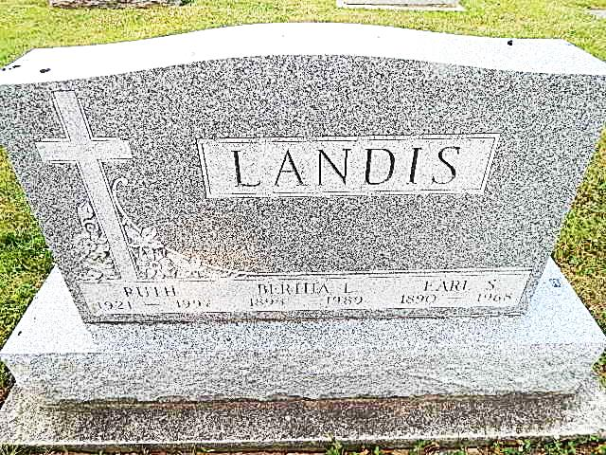
Photo by Alicia Kneuss
Ruth M. Landis, 75, of Decatur died Thursday at Woodcrest Nursing Care Center. The Decatur native was a former employee of Wayne Novelty in Decatur.
Surviving are brothers, Arthur Landis and Willard Landis, both of Decatur, Herman Landis and Cleo J. Landis, both of Columbia City, and Clifford Landis of Monroe.
Services are 3:30 p.m. Sunday at Zwick-Sefton & Jahn Funeral Home. Calling is from 11 a.m. until service time Sunday at the funeral home. Burial will be in Pleasant Dale Cemetery, Decatur. Memorials are to Pleasant Dale Church of the Brethren.

News-Sentinel, Allen County, IN; May 17, 1997
Contributed by Jane Edson

