Emma I. (Norris) Liby
November 28, 1881 – June 10, 1967
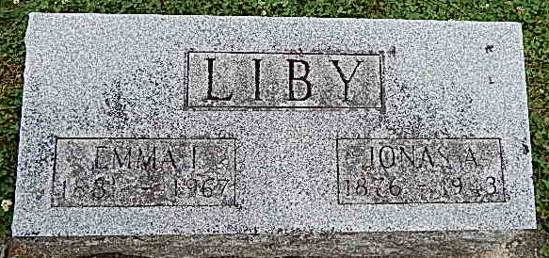
Photo by Alicia Kneuss

Rites Tuesday for Mrs. Emma Liby
Mrs. Emma I. Liby, 85, of 707 West Market St. died at 11:45 a.m. Saturday at the Clark Nursing Home. Death, due to a cerebral hemorrhage, followed an illness of three years.
A native of Darke County, O., Mrs. Liby was born Nov. 28, 1881, a daughter of Marcellus and Chloe Detrick Norris. Her marriage to Jonas Liby, who preceded her in death in 1943, took place in 1902.
Mrs. Liby was a member of the Pleasant Dale Church of the Brethren.
Survivors are two daughters, Mrs. Robert (Edith) Burroughs of Bluffton and Mrs. John (Mary) Donaghy of Ossian Route 2; four sons, Walter of Muncie, Lloyd of Detroit, Lester of Bluffton and Robert of Colton, Calif.
Three sisters, Mrs. John (Nora) Fulk of Bluffton, Mrs. Charles (Vera) Wolfe of Kingsland and Mrs. Rhuben (Alice) Smith of Peterson, 16 grandchildren and 17 great-grandchildren also survive.
Friends may call at the Goodwin Funeral Home, where services will be held at 2 p.m. Tuesday with Rev. Dolar Ritchey officiating. Burial will be in the Pleasant Dale Cemetery.
Bluffton News-Banner, Wells County, IN; June 12, 1967

