Jerry L. Mitchel
July 29, 1938 – June 17, 2018
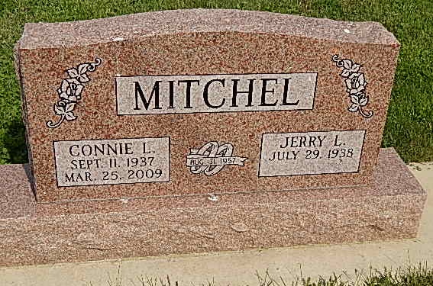
Photo by Alicia Kneuss
Jerry L. Mitchel, 79, of Decatur, Indiana passed away Sunday afternoon, June 17, 2018 at his residence.
He was born on July 29, 1938 in Decatur, Indiana to the late Floyd M. Mitchel and the late Veda (Hawkins) Mitchel. On August 31, 1957 he married Connie L. Liechty in Berne, Indiana and she preceded him in death on March 25, 2009.
Jerry was a graduate of Adams Central High School in 1956. He received his bachelor's degree from Manchester College and his master's degree from Ball State University. He taught four years in Decatur and 29 years in New Haven, where he was also head coach of the varsity basketball team for eight years.
Jerry was a lifelong member of the Decatur Church of God. He became an ordained pastor in the Church of God, Anderson serving the Decatur Church of God as Visitation Minister & as an Interim Pastor in different area churches. Jerry served as a Sunday school teacher for close to 50 years and was currently teaching the senior high class. He also started and continued to work with the Wild Game Dinner that was held at the Decatur Church of God.
Jerry was active with LOVE Inc. and assisted with the basketball program at Adams Central Community Schools. He loved the outdoors particularly fishing and hunting.
He is survived by his daughter, Deb Mitchel of Monroe; son, Dennie (Karyn) Mitchel of Fishers; three grandchildren, Nikki (Joshua) Rosebrough of Grand Forks, ND; Mattheus Mitchel of Indianapolis; & Conlyn Mitchel of Monroe; three brothers, Gene Mitchel & Robert (Pat) Mitchel both of Decatur, & Ned (Judy) Mitchel of Bryant; two brothers-in-law, Evan (Pat) Liechty of Chardon, OH & Dennis (Mary) Liechty of Angola; & two sisters-in-law, Claudia (Barry) Dyment of Geneva & Charlene Duff of Berne.
A funeral service will be held at 10:00 a.m. Thursday, June 21, 2018 at the Decatur Church of God with Rev. Dr. Robert Brink & Pastor Jay Carter officiating. Burial will follow at Pleasant Dale Cemetery.
Family & friends will be received from 12 noon to 8 p.m. Wednesday, June 20, 2018 at the Zwick & Jahn Funeral Home in Decatur and one hour prior to the service at the church on Thursday.
In lieu of flowers donations can be made to the Decatur Church of God Scholarship Program or Adams Central Basketball Program.

Zwick & Jahn Funeral Home online obit (accessed 6/18/2018)

