Chloe Elizabeth (Detrick) Norris
April 13, 1856 – April 3, 1931

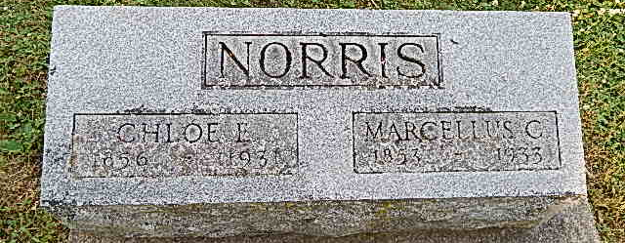
Photo by Alicia Kneuss
Chloe Norris Dies Today
Mother of Monroe Woman Dies at Bluffton This Afternoon
Bluffton, April 3--(Special) Mrs. Chloe E. Norris, 84, died at her home at 421 West Lancaster Street, Bluffton this afternoon at 2 o'clock following a four weeks illness.
The deceased was born April 13, 1856 in Rockingham, Virginia, the daughter of Abraham Detrick and Virginia Judy. She was married in Georgetown, Ohio to N. C. Marcellus, who survives.
The children who survive are Emma I. Liby of Bluffton; Jesse C. Norris of Arcanum, Ohio; Adam W. Norris, William Norris, and Nora Fulk of Bluffton; Virnie Wolf of Waynedale, Esther Kinsey of Richmond, Michigan, and Alice Smith of Monroe. There are two children deceased, Elizabeth Liby and Katherine Norris. John Detrick of Salem, Ohio is the only brother living. The deceased was one of twelve children in the family. Forty-one grandchildren survive.
Funeral services will be held Monday, April 6, at 10 a.m. at the Brethren Church, four miles east of Craigville, with the Rev. D. M. Byerly officiating. Burial will be made in the Pleasant Dale Cemetery.
Decatur Daily Democrat, Adams County, IN; April 3, 1931
*****
MRS. M. C. NORRIS DIES 2 O'CLOCK
DEATH OCCURS AT HOME ON LANCASTER STREET; FUNERAL MONDAY MORNING
Mrs. M. C. Norris, 74, died this afternoon at 2 o'clock at her home, 421 West Lancaster Street, following an illness of four weeks.
Mrs. Norris' maiden name was Chloe Detrick and she was born at Rockingham, Va., a daughter of Abraham and Virginia Detrick. The date of her birth was April 13, 1856.
Her marriage to Mr. Norris, who is living, took place at Georgetown, Darke County, Ohio. She had been a resident of Wells County eleven years.
Following are the sons and daughters who survive: Emma Liby, Bluffton; Jesse C. Norris, Arcanum, O.; Adam W. Norris, Bluffton; Vernie Wolfe, Waynedale; William Norris, Bluffton; Nora Fulk, Bluffton; Esther Kinsey, Richmond, Mich.; Alice Smith, Monroe, Ind. Two daughters, Elizabeth Liby and Katherine Norris, are deceased.
A brother, John Detrick, resides at Salem, O. He is the only living one of a family of twelve children. He is eighty-four years old.
There are forty-one grandchildren living. Three are dead.
Funeral services will be held Monday morning at 10 o'clock at the Brethren church, four miles east of Craigville. Burial will be made at Pleasant Dale.
Evening News-Banner, Wells County, IN; April 3, 1931

