Reuben Pierce
February 26, 1856 – March 16, 1916

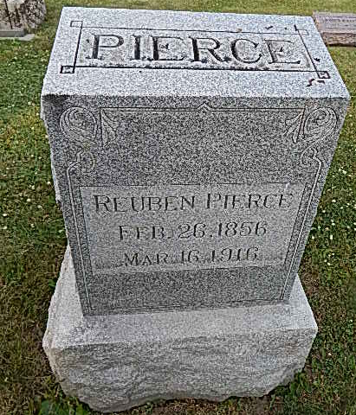
Photo by Alicia Kneuss

BROTHER IS DEAD
Reuben E. Pierce, Former Adams County Resident, Died Suddenly in Jennings County; Body Will be Brought to Home of Sister, Mrs. E. E. Zimmerman
Mrs. E. E. Zimmerman of near Peterson, received word this morning of the sudden death of her brother, Reuben E. Pierce, which occurred yesterday at the home of her brother, Jacob Pierce, in Jennings County, this state.
Mr. Pierce was a former resident of this county, residing west of this city, but for several years has lived in the south part of the state. He was past fifty years of age and was never married.
The body will be brought here, arriving at Peterson over the Clover Leaf Saturday evening at 6:30 o'clock. The body will be taken to the home of E. E. Zimmerman and the funeral will be held Sunday morning, leaving the house at 10:30 o'clock, standard time, for the Pleasant Dale Church where the funeral service will be held.
Surviving brothers and sisters are: John Pierce of near Bluffton; George Pierce and Mrs. Jane Holmes, of Curryville; William Pierce of Detroit, Mich.; Peter Pierce of Fort Wayne; Mrs. Oscar Plank of Craigville; Mrs. Angeline Griffin, of Holland, Mich.
Decatur Daily Democrat, Adams County, IN; March 17, 1916

