John J. Rodich
December 1, 1921 – February 19, 2006

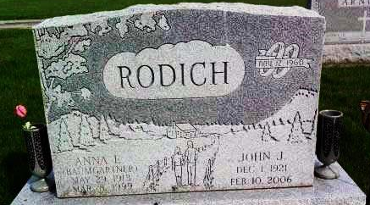
Photo by Deb Curry

John J. Rodich, 84, of Berne, died Friday, Feb. 10, 2006, at Von Regional Medical Center, Selma, Ala. Born Dec. 1, 1921, in Huntington County, Ind., he was the son of the late John and Golda (Murray) Rodich. He married Anna E. (Baumgartner) on Nov. 12, 1960, and she died on March 8, 1999. He was co-owner and operator of John-Ann Beauty Shop for 25 years and volunteered at Adams Memorial Hospital. He was a member of Pleasant Dale Church of the Brethren.
Survived by his son, Robert Rodich of Valley Grande, Ala.; sister, Norma Jean Kaylor of Bossier City, La.; step-daughters, Betty Zerby of Versailles, Ohio, Doris Roth of Marshfield, Mo., Linda (Phil) Wilson of Huntertown, Carol Carroll of Decatur and Kathy (Brent) William of Marion; and three grandchildren. He was also preceded in death by his daughter, Sue Hyndman; one grandson; and brothers, Roy and Jack Rodich.
Service is 10 a.m. Thursday at Haggard & Sefton Funeral Home, Decatur, The Rev. Jay Carter officiating. Calling is from 4 to 6 p.m. Wednesday at the funeral home. Burial at Pleasant Dale Cemetery, rural Decatur, with Military graveside rites by American Legion Post 43. Memorials to Pleasant Dale Church of the Brethren.

Fort Wayne Journal-Gazette (IN); February 14, 2006
Contributed by Jane Edson

