Rodney A. Roth
June 3, 1959 – October 3, 1988

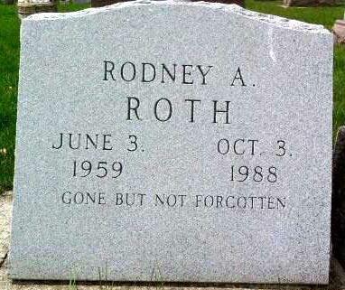
Photo by Deb Curry

Services for Rodney A. Roth, 29, Fort Recovery, O., a native of Decatur, were held this morning at Brockman's Funeral Home, Fort Recovery. Burial was in Pleasant Dale Cemetery in Adams County.
Mr. Roth died Monday evening at his residence of a self-inflicted gunshot wound. He was a self-employed timber buyer and member of the Progressive Sportsman's Club, Fort Recovery. He had attended Mississinewa Valley High School in Darke County, O.
He was born June 3, 1959, in Decatur, the son of Robert and Patricia Arnold-Roth, and was married in Fort Recovery on July 20, 1986, to Diane Rutschilling.
Survivors include the wife; the parents, of Fort Recovery; six brothers, Arnold, Bradley, and Randy, all of Fort Recovery; Anthony, Rose Hill, O.; David, Union City; and Michael, Saratoga; the paternal grandmother, Mrs. Eleanor Lee, Fort Wayne; and the maternal grandparents, Mr. and Mrs. Noah Arnold, Fort Wayne. One brother, Mark, preceded him in death.
Decatur Daily Democrat, Adams County, IN; October 6, 1988

