Anna May (Leimenstall) Rupert
October 10, 1897 – August 15, 1947
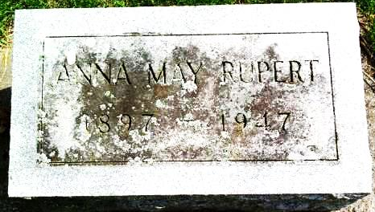
Photo by Deb Curry

Mrs. Anna Rupert Dies at Bluffton
Kirkland Township Lady Dies Friday
Mrs. Anna Rupert, 49, a native of Kirkland Township and wife of Lowell Rupert, died last night at 10 o'clock at the home of a sister, Mrs. Mildred Straw in Bluffton. Death was attributed to carcinoma and followed an illness of one and one-half years.
The deceased was born in Kirkland Township on October 10, 1897 the daughter of Mr. and Mrs. Charles Leimenstall. She was married on October 17, 1928, and was a member of the Christian Union church.
For 11 years she had resided at Spencerville, Ohio.
Surviving are the parents, the husband and the following brothers and sisters: William of Uniondale, Mrs. Mary Fells of Monroeville, Mrs. Hazel Zimmerman of Decatur, Mrs. Martha Crozier of Craigville, Mrs. Straw at Bluffton, Lloyd of Decatur and Walter of Uniondale. Two sisters are deceased.
Funeral services will be held Monday afternoon at 2 o'clock at the Craigville Christian Union church and burial will be in the Pleasant Dale Cemetery in Kirkland Township.
The body will be returned to the home of the parents, one mile east of Craigville, from the Jahn Funeral Home in Bluffton today.
Decatur Daily Democrat, Adams County, IN; August 16, 1947
*****
Mrs. Anna Rupert Answers Summons
Mrs. Anna May Rupert, 49, died at 10 p.m. Friday at the home of a sister, Mrs. Mildred Straw, of 204 East Arnold Street. The decedent had been ill one and a half years, and had been a resident of Spencerville, O., for the last 10 years.
Mrs. Rupert was born Oct. 5, 1897, in Kirkland Township, Adams County, a daughter of Mr. and Mrs. Charles Leimenstall, and was united in marriage to Lowell Rupert Oct. 17, 1928. There were no children born to the union.
Surviving are the husband, the parents, who reside one mile east of Craigville; three brothers, William and Walter Leimenstall of Uniondale, Lloyd Leimenstall of Decatur; four sisters, Mrs. Mary Fells of Monroeville, Mrs. Hazel Zimmerman of Decatur, Mrs. Martha Crozier of Craigville, and Mrs. Mildred Straw of this city. Two sisters are deceased.
The body will be taken from the Jahn funeral home to the home of the parents Sunday morning.
Funeral services will be at 2 o'clock Monday at the Craigville Christian Union church of which the decedent was a member. Rev. J. Smith assisted by Rev. G. M. Sills will officiate at the service. Burial will be in the Pleasant Dale Cemetery in Kirkland Township.
Bluffton News-Banner, Wells County, IN; August 16, 1947

