Edna M. (Ehrman) Shady
June 20, 1901 – June 12, 1987

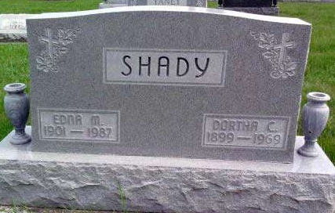
Photo by Deb Curry

Edna M. Shady, 85, route 2, Decatur, died at 5 a.m. today at her residence. She had been in poor health for several months.
She had taught at Kirkland Daily Vacation Bible School and was a First United Methodist Church (where she was a member) Sunday School teacher many years. She also had spent much time attending shut-ins of Decatur and Adams County and played the piano and sang to patients at the Decatur Community Care Center.
She was a member of the Ruth Circle of the church, Kirkland Extension Club, Sunshine Garden Club, WCTU, where she was a former past president, and United Methodist Women.
Born in Adams County on June 20, 1901, she was the daughter of William and Sena Leimenstoll-Ehrman, and was married June 20, 1922, to Dortha C. Shady; he died May 20, 1969.
Survivors include two sons, Donald E. Shady, route 8, Decatur, and William A. Shady, Bluffton; two brothers, Floyd Ehrman, Ossian, and Robert Ehrman, Decatur; five grandchildren; 11 great-grandchildren; four step-grandchildren; and nine step- great-grandchildren.
Services will be Sunday at 2:30 p.m. at First United Methodist Church, Rev. Bill Moon officiating. Burial will be in Pleasant Dale Cemetery. Friends may call at Zwick-Boltz & Jahn Funeral Home after 7 p.m. today, all day Saturday, and until 11 a.m. Sunday, and then at the church from noon until service time Sunday. Memorials are to the church.
Decatur Daily Democrat, Adams County, IN; June 12, 1987
*****
William A. Shady's Mother, Edna M. Shady, 85, Dies; Rites Sunday
Mother of William A. Shady of Bluffton, Mrs. Dortha (Edna M.) Shady, 85, who had been ill several months, died at 5 a.m. today at her home on Decatur Route 2.
A member of the First United Methodist Church in Decatur, Mrs. Shady was a member of United Methodist Women, Ruth Circle, Kirkland Extension Club, Sunshine Garden Club and the WCTU.
Born June 20, 1901 in Adams County, she was a daughter of William and Sena Leimenstoll Ehrman. Her marriage to Dortha C. Shady, who died May 20, 1969, took place June 20, 1922.
Surviving, in addition to the Bluffton son, are another son, Donald E. Shady of Decatur Route 8; two brothers, Floyd Ehrman of Ossian and Robert Ehrman of Decatur, five grandchildren and 20 great-grandchildren.
Calling after 7 p.m. today and until 11 a.m. Sunday will be at the Zwick-Boltz and Jahn Funeral Home in Decatur. At noon Sunday the body will be taken to the First United Methodist Church in Decatur for services there at 2:30 p.m. in charge of Rev. Bill Moon. Burial will be in the Pleasant Dale Cemetery.
Preferred are memorials to the First United Methodist Church in Decatur.
Bluffton News-Banner, Wells County, IN; June 12, 1987

