Walter A. Sills
1899 – July 26, 1977

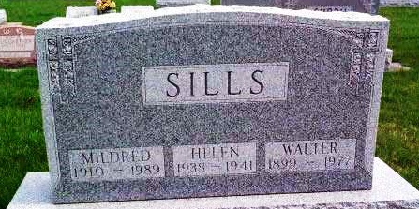
Photo by Alicia Kneuss

Walter A. Sills Dies Suddenly
Walter A. Sills, 77, of 1311 West South St. died at 11:30 a.m. today while picking berries in the Hinshaw strawberry patch at Murray.
Cause of his death was not known immediately.
Surviving is the wife, the former Mildred Miller, four daughters and six sons.
The body was taken to the Thoma-Rich Funeral Home.
Bluffton News-Banner, Wells County, IN; July 26, 1977

