George W. Yaney
February 22, 1901 – December 19, 1993

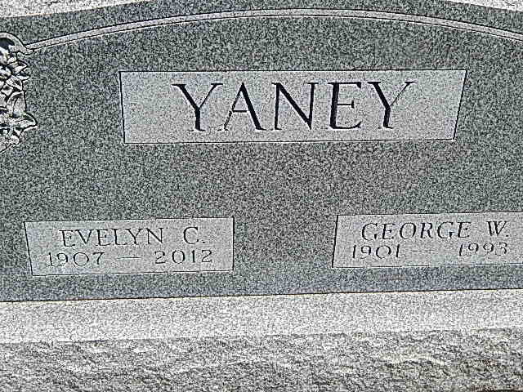
Photo by Alicia Kneuss

George W. Yaney, 92
George W. Yaney, 92, died at 4:47 a.m. Sunday at Wabash County Hospital. He formerly resided at Timbercrest Retirement Community.
Born Feb. 22, 1901 in Adams County, he was a son of I. F. and Dora Macy Yaney. His marriage Nov. 16, 1936 was to the former Evelyn Miller, who survives.
Mr. Yaney was the founder and former owner of Fort Wayne Tiling Co. He was a member of the Lincolnshire Church of the Brethren, Peru Lions Club and Foster Park Lions Club.
Surviving, in addition to the wife, are two sons, Donald L. Yaney of Columbia, Md., and David A. Yaney of Joliet, Ill.; four grandchildren and one great-grandchild.
Friends may call from 9 to 11 a.m. Tuesday at Timbercrest Chapel, where rites will be officiated by Rev. Jerry Peterson and Rev. Glenn Mulligan at 11 a.m. Burial will take place in Pleasant Dale Cemetery, Decatur.
Memorials may be made to the donor's preferred charity.
Arrangements are by DeLaughter-McKee Mortuary, North Manchester.
Bluffton News-Banner, Wells County, IN; December 20, 1993

