Curtis Ledoyle Zimmerman
January 28, 1926 – February 5, 1999

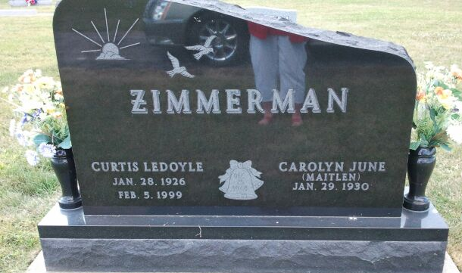
Photo by Marge

Curtis L. Zimmerman, 73, of Decatur, an area farmer, died Friday, Feb. 5, 1999, at home. The Adams County native retired in 1992 from Textron/Micro-Precision in 1990 from farming and was a member of St. Mark's United Methodist Church.
Surviving are his wife, Carolyn J.; a son, Kenn W. of Decatur; a daughter, Barbara E. Zimmerman of Fort Wayne; and two grandchildren. He was preceded in death by a brother and a sister. Services are 10 a.m. Tuesday at Haggard & Sefton Funeral Home, Decatur, with calling from 2 to 8 p.m. today. Burial will be in Pleasant Dale Cemetery, Decatur. Memorials are to St. Mark's music or youth departments.

Fort Wayne News-Sentinel (IN); February 8, 1999
Contributed by Jane Edson

