James Lewis Zimmerman
July 5, 1867 – May 7, 1937

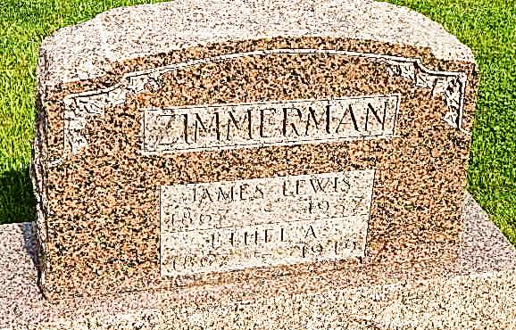
Photo by Alicia Kneuss

J. L. Zimmerman Is Claimed By Death
Kirkland Township Man Dies of Illness Dating From January
James Lewis Zimmerman, 69, died at 3:45 Friday afternoon in his home in Kirkland Township, Adams County, after an illness since January from complications. Born in Kirkland Township on July 5, 1867, Mr. Zimmerman was a son of Peter and Susannah Niblick Zimmerman. His marriage to Ethel Beavers took place on Oct. 28, 1890 in Adams County.
Surviving are the widow; seven children, Daniel, Irvin and Lawrence Zimmerman, all of Adams county; Fred and Seth Zimmerman, of Wells county; William Zimmerman, of Tocsin; Benjamin Zimmerman, of Rapid City, Mich.; and 14 grandchildren.
Brothers surviving are Edward Zimmerman, of Fort Wayne; W.D. Zimmerman of Adams County; Milton Zimmerman, and D.C. Zimmerman both of Kirkland Township. Three sisters, one brother, and two grandchildren are deceased.
Funeral services will be held at 2 o'clock Monday afternoon at the Pleasant Dale Church in charge of Rev. Weller, assisted by Rev. Moore. Burial will be in the church cemetery. Friends are asked to please omit flowers.

Evening News-Banner, Wells County, IN; May 8, 1937

