Christian Amacher
May 15, 1861 – February 11, 1915

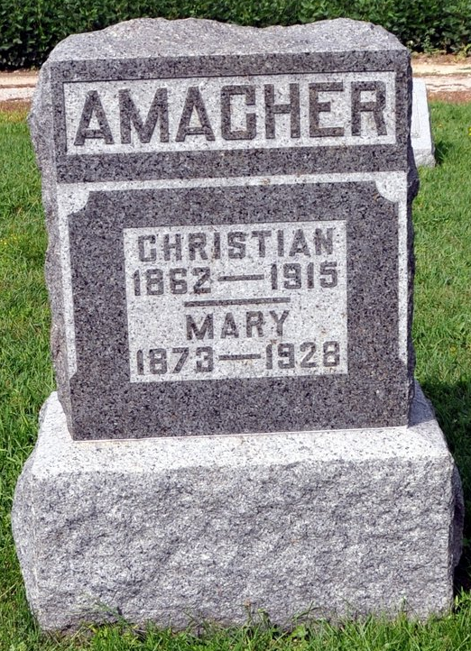

Christ Amacher; Died February 11, 1915 in Kirkland Township from tuberculosis; Married; Farmer; Religion: Ref.; Funeral February 14, 1915 at St. Luke Church; Burial at St. Luke; Charge to Mrs. Christ Amacher; Order given by Mrs. Christ Amacher.

Biery-Yager Funeral Home Record, Adams County, Indiana

*****
DIED AT NOON
Well Known Farmer Died This Morning After Illness of Two Years.
FROM TUBERCULOSIS
Widow and Three Children Survive--Funeral to be Held Sunday.
Christian Amacher, well known farmer, living west of Monroe, died at his home at 10:50 this morning after suffering two years from tuberculosis. The end, though not unexpected, caused much sorrow among his many acquaintances over the county. He was born in Switzerland in 1861 and came to this country when a boy. He had been industrious and a good citizen and his death is deeply regretted. He is survived by the widow and three children, Victor, Margaret and Amelia. One brother, Fred Amacher, who lived in this county until a few months ago, when he returned to Switzerland, also survives. The age of the deceased was fifty-three years, eight months and twenty-seven days. The funeral services will be held Sunday afternoon from the German Reformed church near Honduras.
Decatur Daily Democrat, Adams County, IN; Thursday, February 11, 1915.

