Steven Joe Andrews
September 4, 1969 – September 11, 1985

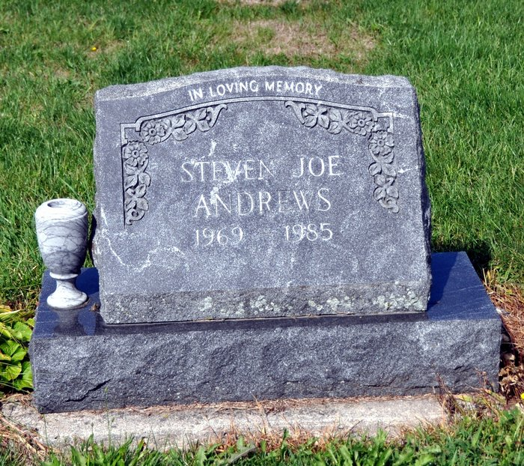

Services for Steven Joe Andrews, 17, son of Mr. and Mrs. Jack Andrews, Route 4, Decatur, will be held Saturday at 2:30 p.m. at Winteregg-Linn & Haggard Funeral Home, Rev. Peter Smith officiating. Burial will be in St. Luke Cemetery. Friends may call at the funeral home from 2-9 p.m. Friday.
A junior at Adams Central, he was a member of the wrestling team. He attended St. Luke's United Church of Christ. Born on Sept. 4, 1969, in Decatur, he was the son of Jack and Patricia Myers-Andrews.
Surviving, in addition to the parents, are six brothers, Donald E. and Ross L. Andrews, both of Monroe; Gary R., Jerry T., Randy W., and Scott D. Andrews, all of Route 4, Decatur; one sister, Laurinda M. Andrews, Route 4, Decatur; and the maternal grandmother, Laura Myers, Route 6, Decatur.
Memorials are to the Adams Central School or St. Luke's United Church of Christ.
Decatur Daily Democrat, Adams County, IN; September 12, 1985

