Thelma Ruth (Darr) Brown
January 23, 1917 – May 22, 1992

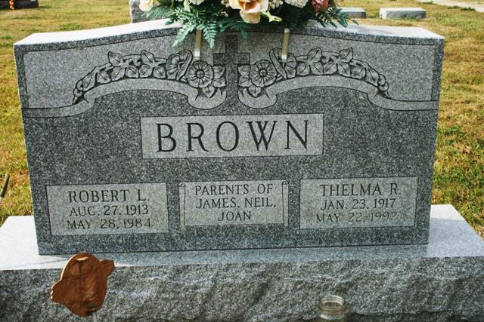

Thelma R. Brown, 75, Route 4, Decatur, died at 3:05 p.m. Friday at Lutheran Hospital, Fort Wayne, shortly after being admitted there.
She was born in Adams County January 23, 1917 to James O. and Bernice (Miller) Darr. She was married to Robert L. Brown on June 1, 1941 in Vera Cruz. She was a homemaker and member of St. Luke's United Church of Christ and the Women’s Guild of the church.
Survivors include two sons, James A. Brown and R. Neil Brown, both of Decatur; a daughter, Mrs. David (Joan) Furey, Ossian; six grandchildren; and a great-grandchild. A brother, Dwight Darr, preceded her in death.
Funeral services are at 11 a.m. Tuesday at St. Luke's United Church of Christ, Rev. Jerry Flueckiger officiating. Visiting hours are 7-9 p.m. Sunday and 4-9 p.m. Monday at Haggard & Armes Funeral Home and an hour prior to services at the church. Burial will be in St. Luke's Cemetery. Memorials are to the Women's Guild of the church.
Decatur Daily Democrat, Adams County, IN; May 23, 1992

