Harold W. Dick
September 26, 1937 – April 5, 2017

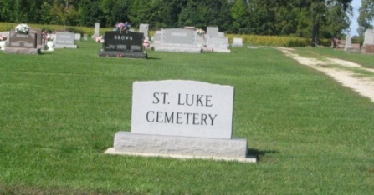

Harold W. Dick, born September 26, 1937 to Albert F. Dick and Virgil Leotis (Andrews) Dick, passed on April 5, 2017 at 9:50 am. He graduated in 1956 from Adams Central High School in Adams County, Indiana. Harold excelled in many sports and did so with remarkable ability. Not only was Harold on the basketball team he was also often the half-time entertainment performing acrobatic feats. In track and field Harold was competitive in each event and held at least one event school record for 30 years. As a baseball player, he was recruited for the position of pitcher with the Cincinnati Reds farm team but lost his hand in a farm related accident and was not able to realize that dream. Harold then continued farming and successfully grew a large grain operation along with varying livestock over the years. As his self-employment in farming ended Harold morphed into a full-time carpenter restoring furniture, building toys, lawn furniture, and buildings. During his later years Harold started and maintained an orchard, became a beekeeper and raised game fowl. These are only a few of Harold’s accomplishments.
He was a member of the St. Luke United Church of Christ on R.R.#4 Decatur, Indiana, enlisted in the United States Air Force Reserve from 1956 to 1962, a charter member of the Portland Optimist Club, and a member of the Whitney Lodge #229, F&AM, New Burlington, Indiana.
Harold is survived by his wife Ina Elaine (Woodruff) Dick and his two children, Bradley Wayne Dick, Detroit, Michigan and Monica Sue Dick, Indianapolis, Indiana. He is also survived by two sisters and two brothers, Alice Liechty, Berne, Indiana and Mary Bean, Anderson, Indiana, Robert Dick, Ft. Wayne, Indiana, and Roger Dick, Cary, North Carolina. Three sisters and three brothers are deceased, Esther Dick, Violet Beck, Doris Sprunger, Edward Dick, Don Dick, and Herman Dick.
A Celebration of Life will be held at St. Luke’s United Church of Christ Community Center in Decatur, Indiana, located at the corner of 100N and 500W, Rural Route 4 on April 29, 2017 from noon to 4pm. Preferred memorials are to IU Health Ball Memorial Hospice, Muncie, Indiana or Little Red Door Cancer Services, Muncie, Indiana.
The Meeks Mortuary and Crematory is in charge of arrangements.
Meeks Mortuary online obit (accessed April 6, 2017)

