Sophia (Stock) Dick
1871 – December 23, 1950

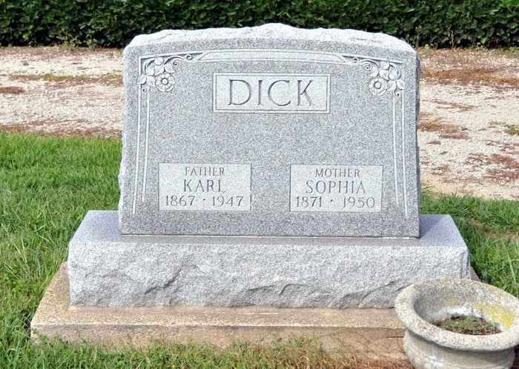

Mrs. Sophia Dick Dies This Morning
Mrs. Sophia Dicks, of Kirkland Township, died at 9:20 o'clock this morning at the home of a daughter, Mrs. Elmer Beer, two miles north of Berne, following a month's illness. She was a member of the St. Luke's Evangelical and Reformed Church. Her husband, Karl Dick, died Nov. 7, 1947.
Survivors include two daughters, Mrs. Beer and Mrs. Clark Funk, of south of Monroe, and one son, Albert Dick of Kirkland township. The body was removed to the Jahn Funeral Home at Bluffton. Funeral arrangements have not been completed.
Decatur Daily Democrat, Adams County, IN; December 23, 1950

