Kathryn C. (Hoffman) Dolch
October 12, 1877 – June 30, 1964

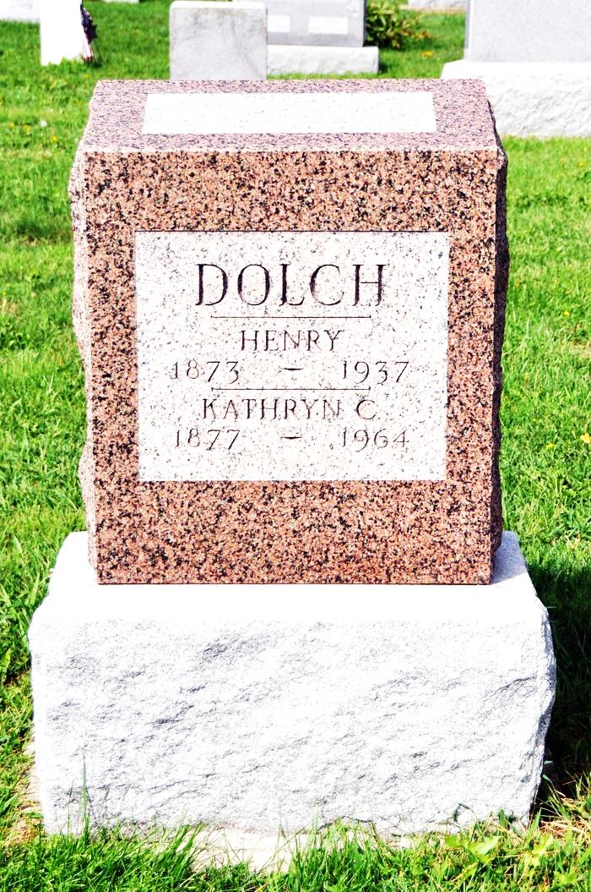

Catherine Dolch Dies Early Today
Mrs. Catherine (sic) Dolch, 86, died at 1:30 o'clock this morning at the South View Nursing Home at Bluffton. She had been in failing health for several years and critically ill for the past three weeks. She was born near Chattanooga, O., Oct. 12, 1877, and was a life-long resident of the Berne community. Her husband, Henry Dolch, preceded her in death a number of years ago.
Mrs. Dolch was a member of the Cross United Church of Christ at Berne.
Surviving are two daughters, Mrs. Enos Neuenschwander of Berne Route 1, and Mrs. Tillman Beer of Monroe Route 1; three sons, Edward Dolch of Portland, and Martin and Albert Dolch of Fort Wayne; one sister, Mrs. Lucy Sheets of Wren, O.; three grandchildren and one great-grandchild.
Funeral services will be conducted at 2 p.m. Thursday at the Yager Funeral Home at Berne, with burial in St. Luke's Cemetery at Honduras. Friends may call at the funeral home after 1 p.m. Wednesday.
Decatur Daily Democrat, Adams County, IN; June 30, 1964

