Lula Mary (Shoaf) Egly
February 13, 1894 – June 27, 1995

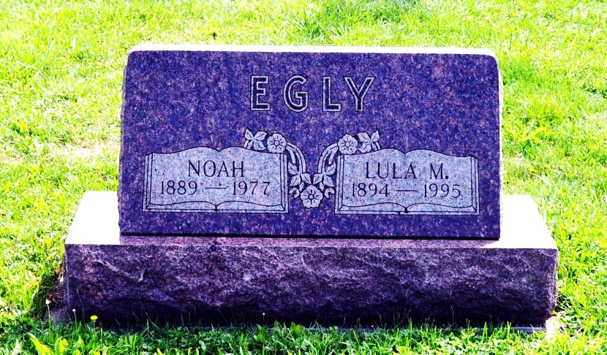

Lula M. Egly, 101, Berne, a former Monroe resident, died at 8:35 p.m. Tuesday in Swiss Village, her residence for some three and one-half years. She was born on February 13, 1894 in Adams County to William and Sadie Benedict Shoaf and married Noah Egly on January 24, 1914. He died on September 9, 1977.
She was a homemaker, a member of St. Luke’s United Church of Christ and its women's guild, and an active quilt maker.
Surviving are three daughters, Mrs. William (Delores) Joray, rural Geneva; Ireta Harmon, Decatur; and Mrs. Arthur (Milita) Moeschberger, Monroe; a sister, Mable M. Liniger, Decatur; eight grandchildren; 16 great-grandchildren; and one great-great-grandchild. Five brothers and three sisters are deceased.
Funeral services will be at 10:30 a.m. Friday in St. Luke's United Church of Christ, with burial in the church cemetery. Visiting hours are 2-9 p.m. Thursday in Haggard and Armes Funeral Home, Decatur, and 9:30-10:30 a.m. Friday in the church.
Preferred memorials are to the church or to Crossroads Children's Home in Fort Wayne.
Decatur Daily Democrat, Adams County, IN; June 28, 1995

