Carrie (Burrie) Klickman
January 27, 1887 – June 26, 1925

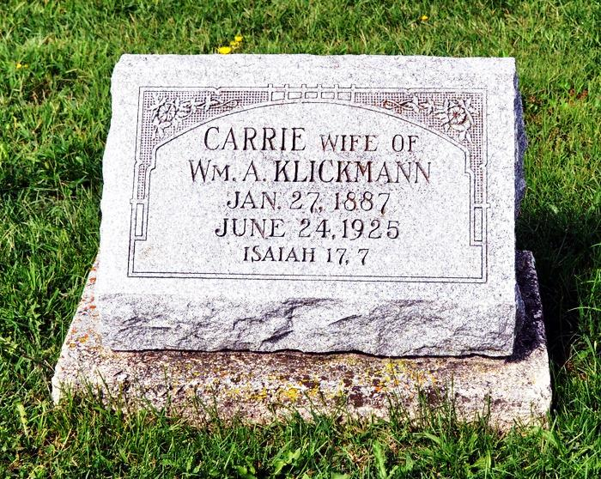
MONROE LADY DIES TODAY
Mrs. William Klickman Expires At Memorial Hospital Here
Mrs. William Klickman, 39, of near Monroe, died at the Adams County Memorial Hospital at nine o'clock this morning, after a short illness. A busted blood vessel was the immediate cause of the death.
She was a member of the St. Luke’s Reformed Church and was a faithful worker in all the church activities. Two children by a former marriage and the husband survive.
No definite funeral arrangements have been made, but it was stated this afternoon that the funeral probably would be held from the St. Luke’s Reformed Church, Sunday afternoon, and burial would take place in the cemetery near the church. Definite arrangements, however, will not be made until tonight or tomorrow.
Decatur Daily Democrat, Adams County, IN; June 26, 1925

