Peter H. Moser
August 11, 1869 – September 15, 1927

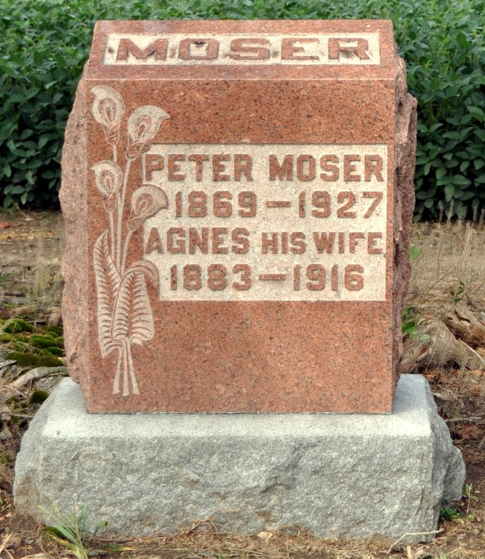
PETER H. MOSER, FARMER, SHOOTS SELF TO DEATH
Heat Believed To Have Caused Adams County Farmer To End His Life
LIFELESS BODY FOUND BY WIFE
Peter H. Moser, 57, one of the best known citizens of the western part of Adams County, ended his life at about 5 o'clock last evening in the hay loft of his barn, shooting himself through his right temple with a thirty-two caliber revolver. He resided in Kirkland Township.
No cause has been ascertained for the rash act, since he left no letter or note of any kind and had been in apparent good health. Mrs. Moser had been away during the afternoon, attending a meeting of her church aid society. She returned home about 4'oclock, and discovered that her husband had not eaten the lunch she had prepared, went to look for him, finding him asleep in his automobile. She awakened him and assisted him to the house.
Wife Hears Shot
Shortly afterward, he seemed to feel better and left the house, his wife presumed that he was going after the cows. A few moments later, she heard a shot and rushing to the barn, found his lifeless body. It is thought most likely that he suffered from the intense heat and that this caused a partial prostration.
The deceased was born in Berne, Switzerland, 57 years ago last month, the son of Mr. and Mrs. Peter Moser, both of whom are deceased. He had lived in this county since a child and was well known as an industrious and excellent citizen. His first wife, who was Miss Agnes Bluhm, died eleven years ago. His second wife was formerly Mrs. Chris Amacher. She survives, together with a number of children and other relatives.
The three sons of the deceased are Frank and Henry Moser, at home, and Raymond Moser, of Decatur. There are also three step-children, Victor Amacher, Mrs. Wilbur Fox and Mrs. Gus Girod, all of this county. The following brothers and sisters also survive: Mrs. Jacob Welfley, Mrs. Fred Kohler and John Moser, French Township; Otto Moser, Berne, and Misses Anna and Kate Moser, of Berne.
Mr. Moser was a member of St. Luke's Reformed Church near Honduras, and the funeral will be held from there at 2 o'clock Saturday afternoon, Rev. Scherry, of Vera Cruz, officiating, and interment in the church cemetery.
Decatur Daily Democrat, Adams County, IN; September 16, 1927

