Albert Presdorf
February 19, 1886 – March 3, 1911

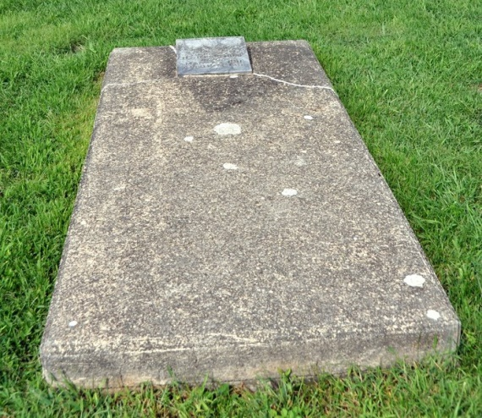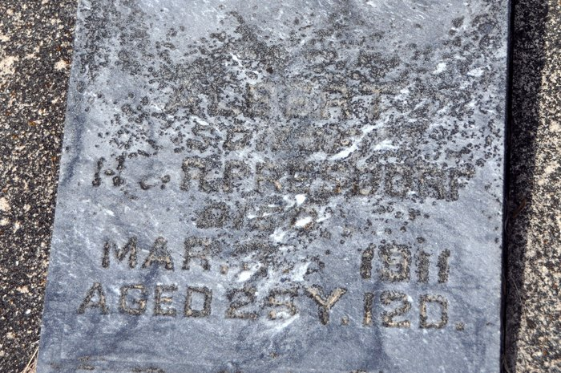
ALBERT PRESDORF DIED OF CONSUMPTION

Albert Presdorf, ex-deputy sheriff, son of Mr. and Mrs. Henry Presdorf, passed away at the home of his parents in French township Friday evening at 5 o’clock, death resulting from tuberculosis. Although his death had been looked for for some time the sad news came as a shock to his many friends and those of the household. His illness had been a lingering one, dating back for several months.
One year ago this month, he left for San Diego, California, with the hopes of finding relief, but after a short stay there it was soon shown that he was obtaining no benefit and decided to go to Phoenix, Arizona, where an uncle, Jacob Meyers, resides. This change did not result in the desired benefit, and he gradually grew worse. He had at first made application to enter the Modern Woodmen home at Colorado Springs, Colo., to take treatment, and where members of this organization are cared for by the order and at the expense of the grand lodge. But owing to the crowded condition of the home at the time he applied, he left for California, the word of acceptance of his application for admittance reaching here after his departure for California.
About six weeks ago he returned to this city with his brother, Noah, of Woodburn, who had gone there to pay him a visit, and went to the home of his parents in French township, they residing two miles south of Honduras.
He was but twenty-five years and five days of age and was born in French township, where he has resided all his life. He served as deputy sheriff under Eli Meyers for about a year in 1909.
He leaves to mourn their loss, besides his father and mother, two brothers and two sisters: Noah, of Woodburn, William, Esther and Beatrice, who are still at home, and a large number of relatives, including the Meyers, Glancey and Klopfenstine families at Preble, an uncle at Berne, and others. Funeral is being held today.

Berne Witness, Adams County, Indiana; Tuesday, March 7, 1911
*****
FUNERAL THIS MORNING
Many Attend Last Sad Rites for Albert Presdorf
The funeral of Albert Presdorf was held Tuesday a. m. at 10 o'clock from the home at Honduras and at 11 o'clock from the Zion Church. A large number of relatives from here were in attendance to pay their last sad respects. Immediately following the later services the remains were brought to this city and placed in the vault at the Decatur Cemetery. The body will later be placed in a cement vault especially made at the St. Luke Cemetery north of Honduras, as its final resting place.
Decatur Daily Democrat, Adams County, IN; March 9, 1911

