Bertha (Ginther) Seesenguth
February 8, 1858 – November 15, 1939

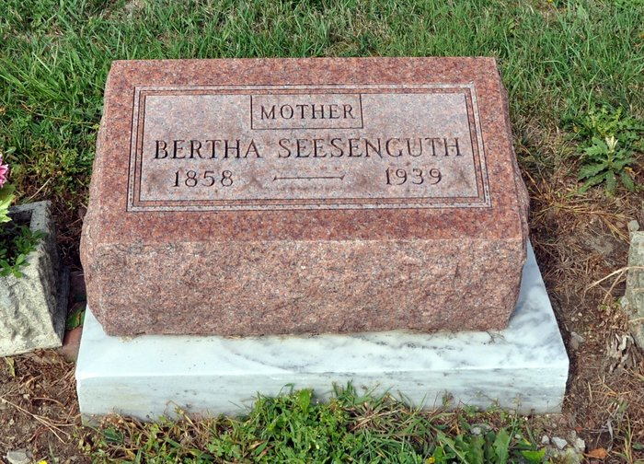
BERTHA SEESENGUTH ANSWERS SUMMONS
DEATH OCCURS AT HOME OF SON AND FUNERAL WILL BE HELD FRIDAY AFTERNOON
Mrs. Bertha Seesenguth, 81, died at 6 o'clock this morning at the home of a son Bert Seesenguth, near Bluffton, from pneumonia and heart trouble. She had been ill since June 4.
Born in Germany, Feb. 8, 1858, the decedent was a daughter of Mr. and Mrs. Fred Ginther. Her marriage to Henry Seesenguth took place May 18, 1881, in Germany. He died in 1891. Mrs. Seesenguth came to America in 1893.
Surviving are two sons, Bert, at whose home she died, and Arnold, near Bluffton, a daughter, Mrs. Emma Stanke, of Chicago, Ill., and four grandchildren. A daughter, a son, two brothers, and a sister are deceased.
The body will be at the Jahn Funeral Home until Thursday morning when it will be taken to the home of the son, Bert.
Funeral services will be held at 1:30 p.m. Friday at the home and at 2 p.m. at the St. John's Evangelical and Reformed Church at Vera Cruz, of which Mrs. Seesenguth was a member, with Rev. H. H. Meckstroth in charge. Burial will be in the St. Luke's Cemetery.
Evening News-Banner, Wells County, IN; November 15, 1939

