Hubert Curtis Shady
August 4, 1902 – April 3, 1926

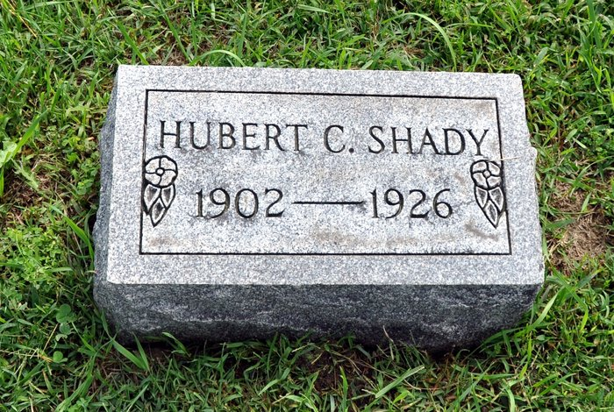
HUBERT SHADY DIES AT HOSPITAL
Decatur Man Succumbs To Illness of Pneumonia Saturday Evening
Hubert C. Shady, 23, died of pneumonia, at the Adams County Memorial Hospital Saturday evening, at 6:30 o'clock. Mr. Shady resided on Eleventh Street, this city, and was employed at the foundry.
Mr. Shady was a son of Mr. and Mrs. Curtiss Shady, residing west of Craigville, where he was born August 4, 1902. On February 8, 1921, he was married to Miss Gladys Corson. He leaves to mourn his untimely death, his wife, Gladys; two children, Virginia Lucille and Max Eugene; his seven brothers, Rollie of Ashtabula, Ohio; Floyd, of Los Angeles, Calif; Ralph, of Tocsin; Roscoe, Charles, Marshall and Joseph at home, and one sister, Mrs. Hazel Reber, of Craigville. One brother, Maxie, died eight years ago.
Mr. Shady was a member of the Zion Reformed Church, from which church the funeral will take place on Tuesday morning at 10:30 o'clock, the Rev. A. R. Fledderjohann, officiating.
Decatur Daily Democrat, Adams County, IN; April 5, 1926

