Edna Mae (Lautzenhiser) Shoaf
May 20, 1917 – July 12, 2011

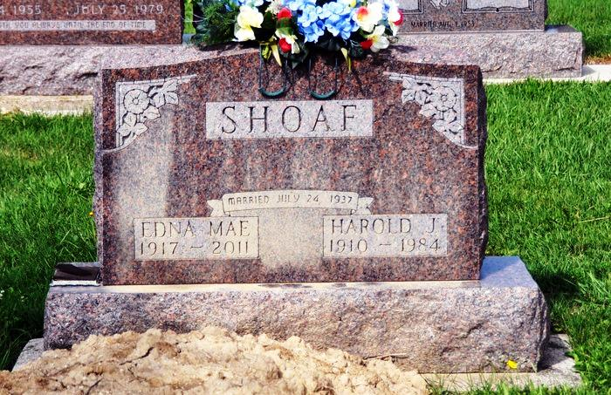
Edna Mae Lautzenheiser Shoaf, age 94, passed away at 8:00 a.m. MST, at the Willow Wood Care Center, in Salt Lake City, Utah on Tuesday, July 12, 2011. She had been in declining health due to mature age; however, death was sudden and unexpected.
Edna Mae was born May 20, 1917 in rural Berne, Indiana, at her parent’s home -- Sidney and Sarah Ethel Detro Lautzenheiser. She was married to Harold J. Shoaf on July 24, 1937 in Decatur, Indiana. Harold preceded his wife in death on Nov 8, 1984 at their retirement home in Florida.
Edna resided in the Decatur, Indiana area with her husband and family most of her married life, however, at retirement they moved to Hernando, Florida where she lived until she migrated back to Indiana and lived at the Chalet Apartments in Berne. In 2005, Edna Mae moved to Utah where she spent time with her daughter Jane in Salt Lake City and Kathy in St. George, Utah. She was a resident of the Willow Wood Care Center in Salt Lake City for the past two years.
She was a graduate of Wren High School and also of Warner Beauty College in Fort Wayne, Indiana. Professionally, she worked several years at Ruth’s Beauty Shop on Adams Street in Decatur and was employed at Decatur Industries prior to her retirement in 1976.
Until recently, Edna was able to relate interesting stories of her youth and events of her life and that of her family. She will forever be remembered for her energy and outgoing personality and her compassion for others. She was skilled in embroidery needlework and until the last year, spent time carefully stitching images on pillow cases and these were cheerfully presented to relatives and friends as cherished gifts.
Edna was preceded in death by her parents Sidney and Ethel Lautzenheiser; brothers: Cleo, Gerald, Eldon, Don and Robert Lautzenheiser and her sister Beatrice Wendell. Her youngest sister, Wanda Lautzenheiser Buck survives and lives in South Carolina.
Surviving are her children: Gary (Jewel) Shoaf of Decatur; Judy Mosshammer (and Ed) North Port, Florida; Kathy (John) Frey of St. George, Utah; Lee (Rosie) Shoaf of Decatur; and Jane (Randy) Edge of Salt Lake City, UT. She is survived by 11 grandchildren and 17 great grandchildren.
The family would like to express fond appreciation and thanks to the staff at Willow Wood Care Center, Salt Lake City, UT for their tender love and care to Mom during her residence there.
Visitation Friday, July 15, 7 to 9 pm at Yager-Kirchhofer Funeral Home and Saturday 1 hour prior to services at the funeral home. Funeral services Saturday, 11 am at the funeral home. Burial in St. Lukes Cemetery, rural Monroe. Memorials are to donor's choice.

Yager-Kirchhofer Funeral Home online obit (accessed 4/6/2015)

